Internship Program

**Dissertation on**

“CLIMATE KNOWLEDGE EXTRACTION USING TEXT AND DATA MINING: AN IPCC CHAPTER CASE STUDY”

Submitted to

Vignan’s Foundation for Science Technology and Research

(Deemed to be University)

In partial fulfillment of the award of the degree of

BACHELOR OF TECHNOLOGY in

BIOINFORMATICS of VFSTR

By

Venkata Sri Satya Gayathri Jonnalagadda

Registration no: 191FA14025

Under the esteemed guidance of

PROJECT CO-ORDINATOR AND INTERN GUIDE

Dr. Gitanjali Yadav

Staff Scientist V

National Institute of Plant Genome Research (NIPGR), New Delhi, India

Lecturer Department of Plant Science,

University of Cambridge

PROJECT HEAD AND INTERN SUPERVISOR

Peter Murray- Rust

Reader Emeritus in Molecular Informatics

Yusuf Hamied Department of Chemistry

University of Cambridge, UK

Faculty guide

Dr. Anand Kumar Nelapati

Assistant Professor, Department of Biotechnology

VFSTR

# NIPGR CERTIFICATE



# CERTIFICATE

This is to certify that **Ms. J.V. S. S. GAYATHRI** bearing the Register No: **191FA14025** of Bachelors of Technology in Bioinformatics, Vignan’s Foundation for Science, Technology & Research (Deemed to be University), Guntur, Andhra Pradesh has carried out the case study embodied in the present dissertation, entitled **“CLIMATE KNOWLEDGE EXTRACTION USING DATA MINING: AN IPCC CHAPTER CASE STUDY”** under the supervision and guidance for a period of five months in partial fulfilment of the requirements for the award of the degree of **B. Tech in Bioinformatics.**

**Head of the Department**

**Internal Examiner**

**External Examiner**

# DECLARATION

I hereby declare that the case study entitled **“CLIMATE KNOWLEDGE EXTRACTION USING TEXT AND DATA MINING: AN IPCC CHAPTER CASE STUDY”** has been carried out by me at the NATIONAL INSTITUTE OF PLANT GENOME RESEARCH, New Delhi, under the supervision and guidance of **Peter Murray- Rust**, Reader Emeritus in Molecular Informatics, Yusuf Hamied Department of Chemistry, University of Cambridge, UK and **Dr. Gitanjali Yadav,** Staff Scientist V, National Institute of Plant Genome Research (NIPGR), New Delhi, India, Lecturer Department of Plant Science, University of Cambridge, UK.

The work carried out is original and no part of the thesis has been submitted for any other degree or diploma to any other University.

**J. V. S. S. Gayathri**

B. Tech in Bioinformatics,

Department of Biotechnology,

Vignan’s Foundation for Science Technology and Research,

Vadlamudi

**DATE**:

# ACKNOWLEDGEMENT

This internship provided by The National Institute of Plant Genome Research (NIPGR) was a great chance for learning and professional development.

I would like to express my sincere gratitude to Dr. Gitanjali Yadav (Scientist, NIPGR;

Lecturer, University of Cambridge) for this opportunity, support, supervision, and encouragement during this internship. I am also obliged to Peter Murray Rust (Reader Emeritus, University of Cambridge) for his patient guidance, life-impacting mentoring, encouragement, and inspiration during my completion.

This period of internship would not have been possible without the constant and unconditional support of all my co-interns, and other team members. I thank them from the bottom of my heart for their wonderful companionship. This internship has been a very good experience for me in a way that it has given me the chance to understand the real world outside the classroom.

Lastly, I express my sincere thanks to Dr. S. Krupanidhi, Dean School of Natural Sciences and Applied Technology, Professor & Head of the Department, Dr. T. C. Venkateswarulu ,

Dr. A. Ranganatha Reddy, Coordinator Bioinformatics & Associate Professor, Department of Biotechnology, Dr. Anand Kumar Nelapati (Faculty guide), Assistant Professor, Department of Biotechnology, Vignan’s Foundation for Science Technology and Research University, for their support and advice to get and complete an internship the in the above-said organization.

I perceive this opportunity as a big milestone for my career development. I shall strive to use gained skills and knowledge in the best possible way. Hope to continue cooperation with all of you shortly

Sincerely,

**J. V. S. S. Gayathri**

# 

# TABLE OF CONTENTS

NIPGR CERTIFICATE

CERTIFICATE

DECLARATION

ACKNOWLEDGEMENT

TABLE OF CONTENTs 1

LIST OF FIGURES 3

LIST OF TABLES 4

LIST OF ABBREVIATIONS 5

ABSTRACT 6

1 DATAMINING 7

1.1 INTRODUCTION TO DATA MINING 7

1.2 ORIGINS AND EARLY APPLICATIONS 8

2 METHODOLOGY FOR KNOWLEDGE EXTRA10

2.1 TEXT MINING IN DATA MINING 10

2.2 CONVENTIONAL PROCESS OF TEXT MINING 11

2.3 PROCEDURE OF ANALYSIS IN TEXT MINING 11

2.4 TEXT MINING TECHNIQUES 12

2.5 AIM & OBJECTIVE 13

3 IPCC CHAPTER: ‘FINANCE & INVESTMENT’14

3.1 INTRODUCTION TO IPCC 14

3.2 CHAPTER 15 ‘FINANCE ANF INVESTMENT’ SUMMARY 14

3.3 LITERATURE RESEARCH 16

3.3.1 PARIS AGREEMENT – FINANCE FOR CLIMATE 16

3.3.2 WHY FINANCE CLIMATE ACTION 17

3.3.3 CLIMATE FINANCE FLOW 17

3.4 FINANCE & INVESTMENT, INDIA (A CASE STUDY) 19

3.4.1 DATA ANALYSIS AND VISUALIZATION 19

3.4.2 OUTCOMES OF THE ANALUSIS AND VISUALIZATION 20

3.4.3 CLIMATE-RELATED DEVELOPMENT: INDIA 23

4 TOOLS EXPLORED FOR TEXT MINING, ANALYSIS AND VISUALIZATION OF IPCC REPORTS 29

4.1 Py4ami 0.0.46 29

4.2 KEYWORD EXTRACTION 31

4.3 DOCANALYSIS 32

4.4 SUMMARIZATION TOOLS 33

4.5 WORD CLOUDS 34

4.6 VOYANT TOOLS 35

4.7 VOSviewer 35

4.8 KNOWLEDGE GRAPHS 36

5 RESULTS and ANALYSIS OF TDM TOOLS

5.1 Py4ami 0.0.46 39

5.2 KEYWORD EXTRACTION 41

5.3 DOCANALYSIS 44

45

5.3.1 Annotating the HTML file 46

5.4 SUMMARIZATION TOOLS 46

5.5 WORD CLOUDS 48

5.6 Voyant Tools 50

5.7 Vos Viewer 51

5.8 KNOWLEDGE GRAPHS 53

CONCLUSION 57

REFERENCES 58

# LIST OF FIGURES

Figure 1 Representation of flow of data mining, image from Data Mining Techniques Applications and Examples – csitweb.com 7

Figure 2 Conventional process of text mining, image from Text Mining in Data Mining - GeeksforGeeks 11

Figure 3 procedure for analysing text mining Figure 4 conventional process of text mining 11

Figure 5 Procedure for analysing text mining, image from Text Mining in Data Mining - GeeksforGeeks 12

Figure 6 Simplified illustration of climate finance architecture, image from OECD document 18

Figure 7 Total climate related development finance, India (2012-2020) 21

Figure 8 Sectoral split of climate related development finance, India (2012-2020), dataset on GitHub 22

Figure 9 Climate theme and financial instrument split, India (2012-2020), dataset on GitHub 23

Figure 10 Total GHG emissions against temperature changes (2008-2020), data from ‘our world data’ 28

Figure 11 Total co2 emissions against temperature change(2008-2020), dataset: ‘our world data’ 28

Figure 12 Representation of working of pyami 40

Figure 13 First page of the chapter’s HTML file on GitHub 40

Figure 14 Keyword extraction tool performed on various data (one example) 42

Figure 15 Python code for keyword extraction (Google colab) 43

Figure 16 Representation and results of Keyword extraction using Python 43

Figure 17 Representation of working and output of docanalysis 44

Figure 18 Python code for docanalysis(by Shwetha N. Hegde, Alum, #SemanticClimate) 44

Figure 19 Manual creation of a Dictionary 45

Figure 20 Python code for annotating HTML file (developed by Ananya Singha, Alum, #SemanticClimate) 46

Figure 21 Quill Bot summariser working on adaptation and mitigation measures (case study) 47

Figure 22 IntelliPPT summariser working on case study data 47

Figure 23 SMMRY summarizer working on case study data 48

Figure 24 Word cloud developed using MonkeyLearn 49

Figure 25 Python code for Word cloud generation,( developed by Ananya Singha, Alum, #SemanticClimate) 49

Figure 26 Word cloud from chapter 'Finance & Investment' 50

Figure 27 Text Visualization using voyant tools 51

Figure 28 VOSviewer: overlay visualization 52

Figure 29 VOSviewer: Density visualization 52

Figure 30 Web of Science portal 52

Figure 31 VOSviewer: Network visualization 53

Figure 32 Obsidian environment- knowledge graph 54

Figure 33 Python code that is used to extract edge from IPCC CHAPTER15 (developed by Dr Peter Murray-Rust) 55

Figure 34 Knowledge graph of chapter ‘Finance & Investment’ developed using python 56

Figure 35 Python code to visualize the extracted nodes as a knowledge graph 56

Figure 36 word cloud developed using MonkeyLearnFigure 37 Python code to visualize the extracted nodes as a knowledge graph 56

# LIST OF TABLES

Table 1 Overview of the categories of finance considered and data source ………………….13

# LIST OF ABBREVIATIONS

1. **AI** Artificial Intelligence
2. **GHG** Green House Gas
3. **HTML** Hyper Text Markup Language
4. **IPCC** Intergovernmental Panel on Climate Change
5. **KG** Knowledge Graph
6. **NAPCC** National Action Plan for Climate Change
7. **NDC** The National Development Council
8. **NLP** Natural Language Processing
9. **NLTK** Natural Language Tool Kit
10. **OECD** Organization for Economic Cooperation and Development
11. **PDF** Portable Document Format
12. **TDM** Text and Data Mining
13. **UN** United Nation
14. **UNDP** United Nations Development Program
15. **UNFCCC** United Nations Framework Convention on Climate Change

# ABSTRACT

Humanity is facing a set of existential challenges, including the handling of the parallel and interconnected crises of climate change. In an effort to address these challenges, international bodies like the Intergovernmental Panel on Climate Change (IPCC) and the Intergovernmental Science-Policy Platform on Biodiversity and Ecosystem Services (IPBES) have been created. These bodies are producing a series of reports that compile scientific information on specific aspects of climate and discuss policy options and other social implications.

So far, these reports have been provided in formats that make it hard to mobilize the knowledge encapsulated in them. The tool chain of pyami includes methods for cleaning up the formatting, for extracting and processing raw text, tables and figures and annotating them semantically with the help of controlled vocabularies, ontologies and Wikidata. The semantic information and the mined information can then be combined in a way that iteratively improves both, eventually resulting in versions of the reports wherein entities like countries or references are semantically marked up and rendered in responsive formats. My contribution as a software explorer and tester towards the developing tool pyami as a part of the SemanticClimate team, intern in this case study results in exploration of various open-source knowledge extraction tools and software’s in comparison of output data with the currently developing open software source pyami.

# DATA MINING

## INTRODUCTION TO DATA MINING

Unprecedented volumes of digital data are being produced as a result of recent significant technical advancements in computer technology's processing power, storage capacity, and interconnectivity. Data mining, a new and interdisciplinary area of computer science, is the study of obtaining meaningful information from such vast data warehouses. It is widely assumed that data mining will have a significant impact on our society because data mining techniques have been widely used to solve problems in business, science, engineering, and government. The growing acceptance that data mining can have real value has resulted in a surge in demand for new data mining technologies and for students with data mining training—students who comprehend data mining techniques, can use them to solve real-world problems, and are prepared for research and development of new data mining methods.[1]

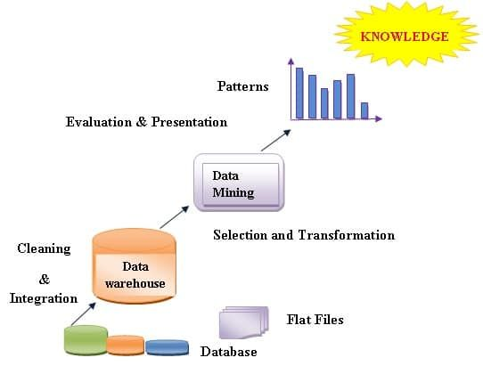Data mining is an interdisciplinary field at the intersection of artificial intelligence, machine learning, statistics and database systems. It is an interdisciplinary subfield of computer science and statistics with an overall goal of extracting information (with intelligent methods) from a data set and transforming the information into a comprehensible structure *(structured data)* for further use.

Figure 1 Representation of flow of data mining, image from [Data Mining Techniques Applications and Examples – csitweb.com](https://www.csitweb.com/data-mining-techniques-applications-and-examples/)

Data mining is the analysis step of the "knowledge discovery in databases" process, or KDD. Aside from the raw analysis step, it also involves database and data management aspects, data pre-processing, model and inference considerations, interestingness metrics, complexity considerations, post-processing of discovered structures, visualization, and online updating.

The term "data mining" is a misnomer because it refers to any type of large-scale data processing, including data extraction, collection, warehousing, analysis, and statistics, as well as any use of artificial intelligence (such as machine learning) and business intelligence in computer decision support systems. The actual data mining task entails the semi-automatic or automatic analysis of massive amounts of data to uncover novel, intriguing patterns, including collections of data records (cluster analysis), records that are out of the ordinary (anomaly detection), and dependencies (association rule mining, sequential pattern mining). Typically, database approaches like spatial indices are used for this. When employed in additional analysis or, for instance, machine learning, these patterns can be thought of as a sort of summary of the input data as well as predictive analytics. A decision support system can use the data mining stage, for instance, to find several groups in the data and use those groups to provide predictions that are more accurate. Although they are included in the overall KDD process as supplementary steps, neither data collection nor preparation nor result interpretation nor reporting are a component of the data mining step.

## ORIGINS AND EARLY APPLICATIONS

Many businesses started storing more transactional data as computer storage capacity increased in the 1980s. Traditional statistical methods could not be used to evaluate the resulting record collections, often known as data warehouses, due to their size. A number of computer science conferences and workshops examined how recent developments in artificial intelligence (AI)—such as findings from expert systems, genetic algorithms, machine learning, and neural networks—could be adapted for knowledge discovery, the term preferred in the computer science community. As a result of the process, the First International Conference on Knowledge Discovery and Data Mining, held in Montreal in 1995, and the publication of Data Mining and Knowledge Discovery in 1997 both came about. Many early data-mining businesses and products were also developed during this time.

One of the earliest successful applications of data mining, perhaps second only to marketing research, was credit-card-fraud detection. By studying a consumer’s purchasing behaviour, a typical pattern usually becomes apparent; purchases made outside this pattern can then be flagged for later investigation or to deny a transaction. However, the wide variety of normal behaviours makes this challenging; no single distinction between normal and fraudulent behaviour works for everyone or all the time. Every individual is likely to make some purchases that differ from the types he has made before, so relying on what is normal for a single individual is likely to give too many false alarms. One approach to improving reliability is first to group individuals that have similar purchasing patterns, since group models are less sensitive to minor anomalies. For example, a “frequent business travellers” group will likely have a pattern that includes unprecedented purchases in diverse locations, but members of this group might be flagged for other transactions, such as catalogue purchases, that do not fit that group’s profile.

Some of the other business problems and solutions found using data mining technology are

*Provident Financials’ Home credit Division, United Kingdom,* challenges such as lack of a system to detect and prevent fraud were faced which are resolved by data mining that resulted in reducing frequency and magnitude of agent-customer fraud, saved money through early fraud detection, saved investigators time and increased prosecution rate [2]

# METHODOLOGY FOR KNOWLEDGE EXTRACTION

## TEXT MINING IN DATA MINING

Text mining is a component of data mining that deals specifically with unstructured text data. It involves the use of ***natural language processing (NLP***) techniques to ***extract useful information*** and insights from large amounts of unstructured text data. Text mining can be used as a pre-processing step for data mining or as a standalone process for specific tasks.

Text mining can be used to extract structured information from unstructured text data such as:

* Named Entity Recognition (NER): Identifying and classifying named entities such as people, organizations, and locations in text data.
* Sentiment Analysis: Identifying and extracting the sentiment (e.g., positive, negative, neutral) of text data.
* Text Summarization: Creating a condensed version of a text document that captures the main points.
* Topic Modelling: Identifying the main topics present in a document or collection of documents.
* Text Classification: Assigning predefined categories to text data.

Text mining is widely used in various fields, such as natural language processing and information retrieval. Rapid increment in computerized or digital information has prompted an enormous volume of information and data. A substantial portion of the available information is stored in Text databases, which consist of large collections of pdfs from various sources. More than 80% of the present information is in the form of unstructured or semi-organized data. Traditional information retrieval techniques become inadequate for the increasingly vast amount of text data. Thus, text mining has become an increasingly popular and essential part of Data Mining. The discovery of proper patterns and analysing text documents from a huge volume of data is a major issue in real-world application areas.

Text mining is a multi-disciplinary field based on data recovery, Data mining, AI, statistics, Machine learning, and computational linguistics.

## CONVENTIONAL PROCESS OF TEXT MINING

There are five fundamental steps involved in the conventional process of text mining:[3]

* Gathering unstructured information from various sources accessible in various document organizations, for example, plain text, web pages, ***PDF records***, etc.
* Pre-processing and data cleansing tasks are performed to distinguish and eliminate inconsistency from the data. The data cleansing process makes sure to capture the genuine text, and it is ***performed to eliminate stop words stemming***.
* Processing and controlling tasks are applied to review and further clean the data set.
* Pattern analysis is implemented in Management Information System.
* 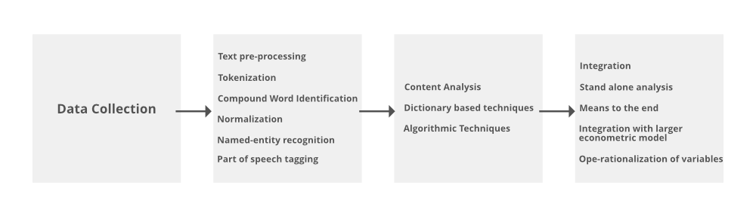Information processed in the above steps is utilized to extract important and applicable data for a powerful and convenient decision-making process and trend analysis.

Figure 2 Conventional process of text mining, image from [Text Mining in Data Mining - GeeksforGeeks](https://www.geeksforgeeks.org/text-mining-in-data-mining/)

Figure 3 procedure for analysing text mining Figure 4 conventional process of text mining

## PROCEDURE OF ANALYSIS IN TEXT MINING

There are three important steps for analysing text mining [3]

* *Text summarization*: to extract its partial content reflection from its whole content automatically.
* *Text categorization*: to assign a category to the text among categories predefined by users*.*
* *Text clustering;* segment texts into several clusters, depending on the substantial relevanc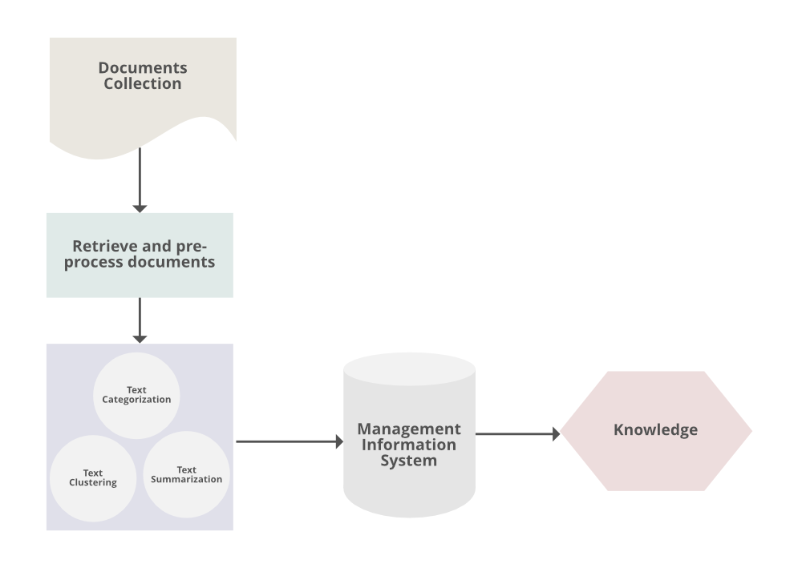e.

## TEXT MINING TECHNIQUES

Techniques of text-data mining:

* ***Information extraction***: It is a process of extracting meaningful words from documents.

Figure 5 Procedure for analysing text mining, image from [Text Mining in Data Mining - GeeksforGeeks](https://www.geeksforgeeks.org/text-mining-in-data-mining/)

* ***Information retrieval***: It is a process of extracting relevant and associated patterns according to a given set of words or text documents.
* ***Natural language processing***: It concerns the automatic processing and analysis of unstructured text information.
* ***Clustering***: It is an unsupervised learning process that grouping of text according to their similar characteristics.
* ***Text summarization***: To extract its partial content reflection it’s whole content automatically.

## AIM & OBJECTIVE

Knowledge extraction from large PDFs (especially scientific literature) is a tough task as these documents are neither human-friendly nor machine-friendly but, the information that a PDF holds is important. Here comes the role of Text and Data mining where we are extracting structured information from the unstructured data with the existing Python packages and libraries and aiming to develop a new Python tool which consists of all the segments that could extract useful knowledge like keywords, key phrases, abbreviations to generate dictionaries, word clouds and knowledge graphs that connects all the information which shows the main link between different aspects of all the extracted information and also create new structures for navigation, search, and display.

The data stored in the IPCC reports is heterogeneous and lack semantics which holds back the creation of knowledge. We, the group ***#SemanticClimate*** a team of young science students aims at creating tools that helps us save time, gain meaningful insights by performing several analysis and extract/liberate knowledge and make it available to the world for accessing and mitigate the effects of gaseous emission. knowledge that can save the world from grave climate change consequences is limited to these IPCC reports [5].

# IPCC CHAPTER: ‘FINANCE & INVESTMENT’

## INTRIDUCTION TO IPCC

**The Intergovernmental Panel on Climate Change** (IPCC) is an intergovernmental body of the United Nations. Its responsibility is to increase scientific understanding of the effects of human activity on the climate. Governments are informed about the state of climate change research by the IPCC. It achieves this by reviewing all pertinent scientific literature on the topic. Natural, economic, and social consequences and hazards are all included in this. It also discusses potential courses of action. The IPCC doesn't carry out its own independent research. To carry out its scientific job, the IPCC maintains three working groups and a task force. It makes an effort to be thorough and unbiased. Numerous scientists and other professionals offer their time to review the papers. For policymakers and the public, they assemble major findings into "Assessment Reports"; experts have referred to this work as the largest peer review process in the scientific community.

Till 2023, IPCC has released six assessment reports, which have three working groups and number of chapters in each working group. This chapter ‘Finance and Investment’ is a part of the latest, i.e., **sixth assessment report**, and a **third working group (IPCC AR6 WG3)**.

## CHAPTER 15 ‘FINANCE ANF INVESTMENT’ SUMMARY

Finance to reduce net greenhouse gas emissions and enhance resilience to climate impacts represents a critical enabling factor for the low carbon transition. Fundamental inequities in access to finance as well as its terms and conditions, and countries exposure to physical impacts of climate change overall result in a worsening outlook for a global just transition. Decarbonising the economy requires global action to address fundamental economic inequities and overcome the climate investment trap that exists for many developing countries. The rising public fiscal costs of mitigation, and of adapting to climate shocks, is affecting many countries and worsening public indebtedness and country credit ratings at a time when there were already significant stresses on public finances.

The Paris Agreement is an important factor in reducing net greenhouse gas (GHG) emissions and enhancing resilience to climate impacts. However, there are many challenges to commercial climate finance, such as the mismatch between capital and investment needs, home bias considerations, differences in risk perceptions for regions, and limited institutional capacity to ensure safeguards. Investors, central banks, and financial regulators are driving increased awareness of climate risk, but there is limited evidence that this attention has directly impacted emission reductions. This leaves high uncertainty, both near-term (2021-30) and longer-term (2021-50), on the feasibility of an alignment of financial flows with the Paris Agreement. The most important details of the phrase’s climate financing, climate change, risks, and GHG are that there is a climate financing gap which reflects a persistent misallocation of global capital, and that global climate finance is heavily focused on mitigation.

To meet the needs for rapid deployment of mitigation options, global mitigation investments are expected to need to increase by the factor of 3 to 6. This represents a major challenge for developing countries, especially Least Developed Countries (LDCs), where flows have to increase by factor 4 to 8. Financing needs for the creation and strengthening of regulatory environment and institutional capacity, upstream financing needs as well as R&D and venture capital for development of new technologies and business models are often overlooked despite their critical role to facilitate the deployment of scaled-up climate finance. The Paris Agreement is a commitment by countries and stakeholders in the financial system to scale up climate finance. Delayed climate investments and financing will result in significant carbon lock-ins, stranded assets, and other additional costs.

A common understanding of debt sustainability and debt transparency has not yet been developed. Greater urgency of action to remain on a 1.5°C pathway requires parallel investment decisions in upstream and downstream parts of the value chain. There is a mismatch between capital availability in the developed world and future emissions expected in developing countries. Global cross-border mitigation financing is essential for vulnerable and poor countries due to high costs of financing, debt stress and the impacts of climate change. Ambitious global climate policy coordination and stepped-up climate financing can help address macroeconomic uncertainty, alleviate developing countries’ debt burden post-COVID-19, redirect capital markets, and reduce up-front risks.

Credible signalling by governments and the international community can reduce uncertainty for financial decision-makers and help reduce transition risk. The mutual benefits of coordinated support for climate mitigation and adaptation in the next decade for both developed and developing regions could potentially be very high in the post-Covid era. Climate compatible stimulus packages could significantly reduce the macro-financial uncertainty generated by the pandemic and increase the sustainability of the world economic recovery. Political leadership and intervention remain central to addressing uncertainty as a fundamental barrier for a redirection of financial flows.

Existing policy misalignments – for example in fossil fuel subsidies – undermine the credibility of public commitments, reduce perceived transition risks and limit financial sector action. Innovative financing approaches could help reduce the systemic under-pricing of climate risk in markets and foster demand for Paris-aligned investment opportunities. Approaches include de-risking investments, robust ‘green’ labelling and disclosure schemes, in addition to a regulatory focus on transparency and reforming international monetary system financial sector regulations. These relatively new labelled financial products will help by allowing a smooth integration into existing asset allocation models.

Examples include sustainable development goals and environmental, social and governance disclosure, scenario analysis and climate risk assessments, including the Task Force on Climate-Related Financial Disclosures. The outcome of these market-correcting approaches on capital flows cannot be taken for granted, however, without appropriate fiscal, monetary and financial policies. Mitigation policies will be required to enhance the risk-weighted return of low emission and climate resilient options, and - supported by progress in transparent and scientifically based projects’ assessment methods - to accelerate the emergence and support for financial products based on real projects, such as green bonds, and phase out fossil fuel subsidies. Greater public-private cooperation can also encourage the private sector to increase and broaden investments, within a context of safeguards and standards, and this can be integrated into national climate change policies and plans.

## LITERATURE RESEARCH

### PARIS AGREEMENT – FINANCE FOR CLIMATE

DATA MINED FROM: [Climate Finance | United Nations](https://www.un.org/en/climatechange/raising-ambition/climate-finance)

The Paris Agreement [4] recognises the need for specialised climate financing and advocates for "making finance flows consistent with a pathway towards low greenhouse gas emissions and climate-resilient development." Making infrastructure more durable also cuts down on emissions while minimising the wide-ranging effects of natural catastrophes on people's livelihoods and well-being, especially those who are most vulnerable, as well as on businesses and economies. This is because more robust infrastructure avoids expensive repairs and is less likely to cause damage. Furthermore, by 2030, a transition to resilient, low-carbon economies could generate nearly 65 million net new jobs worldwide.

Efforts under the Paris Agreement are guided by its aim of making finance flows consistent with a pathway towards low greenhouse gas emissions and climate-resilient development. Assessing progress in provision and mobilization of support is also part of the global stock take under the Agreement. The Paris Agreement also places emphasis on the transparency and enhanced predictability of financial support. The Agreement itself calls for implementation that reflects “equity and the principle of common but differentiated responsibilities and respective capabilities, in the light of different national circumstances.”

### WHY FINANCE CLIMATE ACTION

LITERATURE RESEARCH FROM UN WEBSITE : [Climate Finance | United Nations](https://www.un.org/en/climatechange/raising-ambition/climate-finance)

The world won't be able to meet its climate targets if we don't invest in the right places. It will boost global temperatures by more than 1.5 degrees Celsius, worsening climate effects that would endanger everyone's health, livelihood, and general well-being. Significant financial investments are needed to combat climate change, such as in infrastructure and new energy systems. However, taking no action on climate is far more expensive.[5], [6]

All nations must cut their emissions and prepare for climate change. However, many developing nations lack the means and know-how to do so. All states concurred that wealthy, technologically advanced industrialised nations must step up and boost their financial support for climate action in developing countries, especially the most vulnerable and impoverished. In order to combat climate change, international cooperation is crucial.

### CLIMATE FINANCE FLOW

DATA FROM: [Aggregate Trends of Climate Finance Provided and Mobilised by Developed Countries in 2013-2020 | en | OECD](https://www.oecd.org/environment/aggregate-trends-of-climate-finance-provided-and-mobilised-by-developed-countries-in-2013-2020-d28f963c-en.htm)

The OECD (Organization of Economic Co-operation and Development) report [7]“Aggregate Trends of Climate Finance Provided and Mobilised by Developed Countries in 2013-2020”,released in July 2022, have given us the aggregate data and trends to 2020, the original target year of the USD 100 billion goal. The latest report provides us graphics and comparisons of the climate finance provided and mobilized over the years 2016-2020. Climate finance flow happens with a specific architecture from sender to receiver

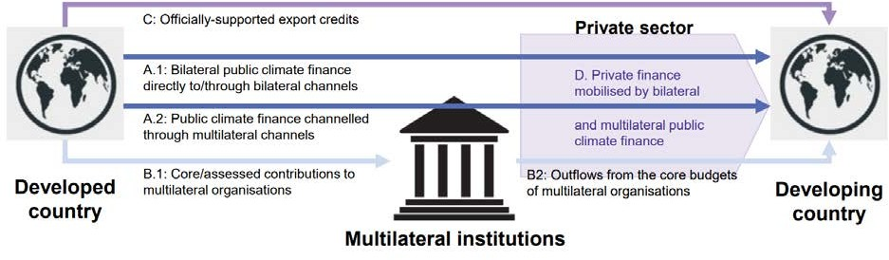

Figure 6 Simplified illustration of climate finance architecture, image from [OECD document](Aggregate%20Trends%20of%20Climate%20Finance%20Provided%20and%20Mobilised%20by%20Developed%20Countries%20in%202013-2020%20|%20en%20|%20OECD)

Table 2Overview of the categories of finance considered and data source, from [OECD document](Aggregate%20Trends%20of%20Climate%20Finance%20Provided%20and%20Mobilised%20by%20Developed%20Countries%20in%202013-2020%20|%20en%20|%20OECD)

|  |  |  |  |
| --- | --- | --- | --- |
| **CATEGORY** | **COVERAGE** | **INSTRUMENTS** | **DATASOURCE** |
| ***Bilateral public*** | Climate finance outflows from donor countries’ bilateral development finance agencies  and institutions | Grants, loans, equity investments (USA only: developmental guarantees) | Biennial reports to the UNFCCC and complementary data submissions |
| ***Multilateral public (attributed to developed countries)*** | Climate finance outflows from multilateral development banks and climate funds attributable to developed countries. | Grants, loans, equity investments | OECD Development Assistance Committee statistics (total multilateral outflows); institutions’ annual reports (for calculating  attribution shares) |
| ***Export credits*** | Climate-related export credits provided by developed countries’ official export credit agencies,  mostly for renewable energy | Export credit loans, guarantees, and insurance | OECD Export Credit Group statistics and complementary data submissions |
| ***Mobilised private (attributed to developed countries)*** | Private finance mobilised by bilateral and multilateral public climate finance | Private finance mobilized by grants, loans, mezzanine/hybrid finance, equity and developmental guarantees. | OECD Development Assistance Committee statistics and complementary data submissions |

## FINANCE & INVESTMENT, INDIA (A CASE STUDY)

This case study mainly focuses on the climate finance provided to India and its investments in various sectors. This analysis is carried out with the climate related development finance data provided by the OECD library and thus diving into the sector specific details, mined from official website of the ministry of environment, forest and climate change, government of India.

Along with the statistical data of the sector specific investments, extraction of text data has also become an important goal, that is later used to build a knowledge graph.

### DATA ANALYSIS AND VISUALIZATION

**Tableau Software**

Tableau software is an American interactive data visualization software company that is focused on business intelligence. There are several products given by this software, tableau public and tableau server are used for this case study.

Tableau Software is able to connect to a variety of data sources, including plain text files (.txt and.csv), Microsoft Excel (.xlsx), Microsoft Access (.accdb), import from a Tableau workbook (.tbm), and Tableau Table data Extract (.tds). Additionally, it has other features including numerous chart formats and mapping capabilities in addition to drag & drop.

Tableau Public is a desktop application that enables us to connect to, examine, and visualise our data file. These analyses are all saved on the internet tableau server together with our personal profile information.

Because it offers capabilities like automatic data type expression and simple filtering and analysis processes with just a click of the mouse, this programme is superior to the standard data analysis and visualisation tool like excel.

**Software:**

<https://www.bing.com/search?q=tableau&qs=HS&pq=tab&sc=10-3&cvid=F04266C2E8AD4BAB9A6F5725DE4CAB0E&FORM=QBRE&sp=1&ghc=1&lq=0&ntref=>1

**THE DATASET**

The data ‘climate related development finance’, analysed and visualized using tableau software is a large XL/CSV file with 2086 entries, which contains provider/donor countries, adaptation finance, mitigation finance, total climate finance, sector specific details, financial instrument used by the provider.

**Data availability**:

<https://github.com/petermr/semanticClimate/blob/5ba00393451e2b649185290d3ff77b44adc5407a/ipcc/ar6/wg3/Chapter15/climate%20related%20development%20finance%20india%202012-2020.csv>

**analysed data** **and graphs**: [Profile - venkata.sri.satya.gayathri.jonnalagadda | Tableau Public](https://public.tableau.com/app/profile/venkata.sri.satya.gayathri.jonnalagadda)

### OUTCOMES OF THE ANALUSIS AND VISUALIZATION

**TOTAL ‘CLIMATE FINANCE’ 2012-2020**

The OECD library provides us with the total data of ***climate related development finance*** mobilized to INDIA from 2012-2020. The [data](https://github.com/petermr/semanticClimate/blob/5ba00393451e2b649185290d3ff77b44adc5407a/ipcc/ar6/wg3/Chapter15/climate%20related%20development%20finance%20india%202012-2020.csv) represents donor perspective of the mobilisation divided into various sectors, financial instrument and adaptation and mitigation funds provided by the donor countries. The available data was connected to ***tableau,*** a non-coding data analysis and visualization software to visualize in the form of charts and graphs. This software makes our work easy such that user should only do very few steps.[8]

**Analysis: Japan and Germany were the largest donors with a total of $ 23037656.07 (in USD thousand) and $7042193.22(in USD thousand) over the years of 2012-2020**

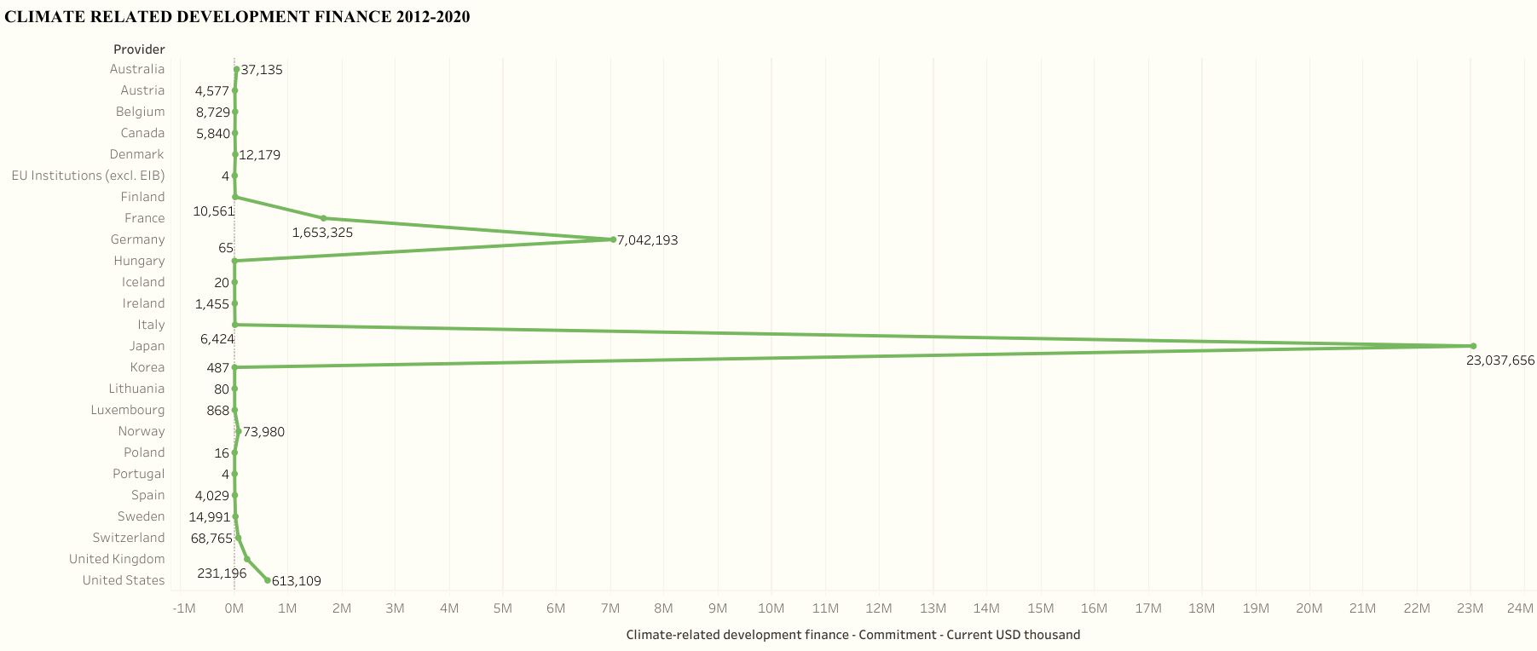

Figure 7 Total climate related development finance, India (2012-2020)

*Note: Data analysis using tableau****,*** [*Dataset on GitHub*](https://github.com/petermr/semanticClimate/blob/5ba00393451e2b649185290d3ff77b44adc5407a/ipcc/ar6/wg3/Chapter15/climate%20related%20development%20finance%20india%202012-2020.csv)

**SECTOTRAL SPLIT OF TOTAL CLIMATE RELATED FINANCE, INDIA 2012-2020**

The total ‘climate finance’ is actually divided into several sectors like agriculture, forestry & fishing, energy, transport, banking, business, health, education, water supply and sanitation, etc.

**Analysis: the sectors ‘transports & storage’ and ‘energy’ are the largest recipients of funds followed by agriculture, forestry and fishing, general environmental development and other sectors.**

**However, this order may vary depending upon the actual utilization of the sector specific finance invested by countries state governments.**

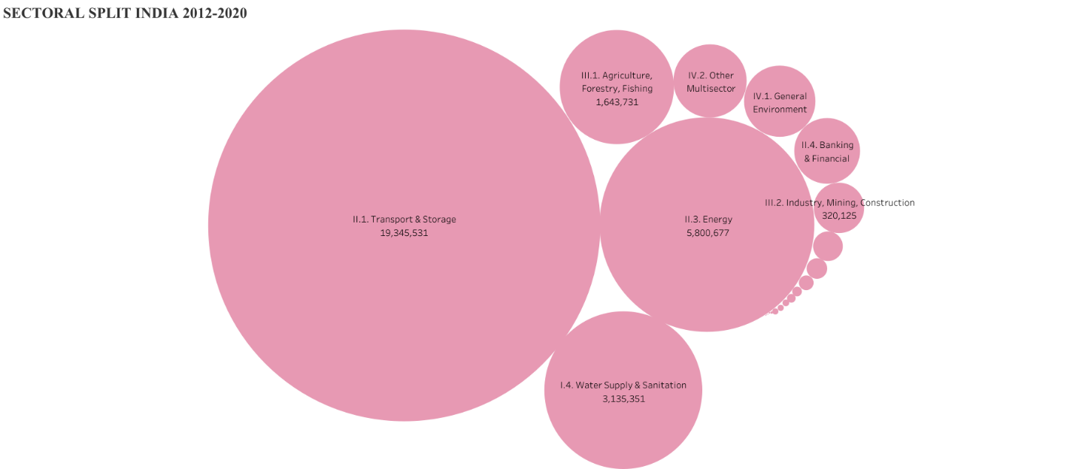

Figure 8 Sectoral split of climate related development finance, India (2012-2020), [dataset on GitHub](https://github.com/petermr/semanticClimate/blob/5ba00393451e2b649185290d3ff77b44adc5407a/ipcc/ar6/wg3/Chapter15/climate%20related%20development%20finance%20india%202012-2020.csv)

**FINANCIAL INSTRUMENT AND CLIMATE THEME SPLIT OF TOTAL FINANCE PROVIDED, INDIA (2012-2020)**

The financial instrument mentioned in the division of the provided amount is debt, grant and equity.

Simple meanings of debt, grant and equity:

* ***Debt***: Debt is an obligation that requires one party, the debtor, to pay money or other agreed-upon value to another party, the creditor.
* ***Grant***: a sum of money given by a government or other organization for a particular purpose .
* ***Equity:*** equity is an ownership interest in property that may be offset by debts or other liabilities.

Climate theme refers to either ***Adaptation*** or ***mitigation***, to which the total mobilized amount is being dedicated.

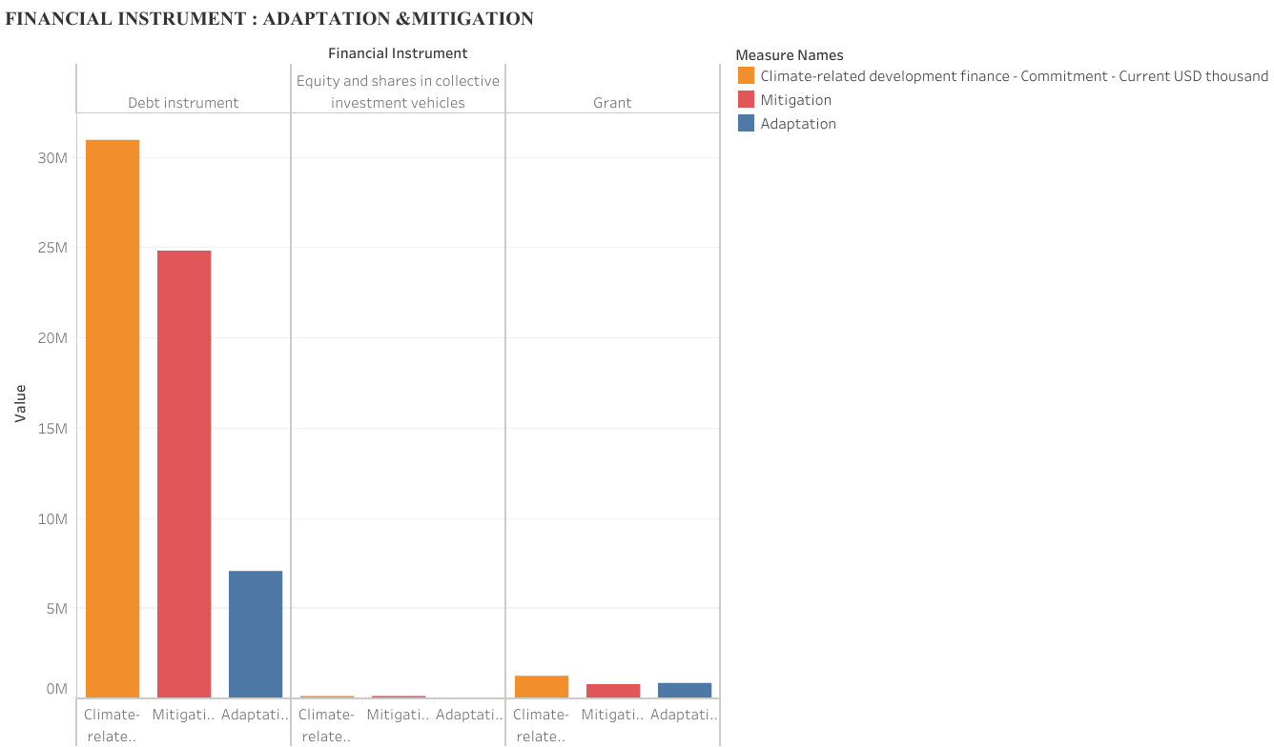**Analysis: The largest type of finance provided to India is in the form of *debt* most of it was dedicated to adaptation**

Figure 9 Climate theme and financial instrument split, India (2012-2020**),** [**dataset on GitHub**](https://github.com/petermr/semanticClimate/blob/5ba00393451e2b649185290d3ff77b44adc5407a/ipcc/ar6/wg3/Chapter15/climate%20related%20development%20finance%20india%202012-2020.csv)

### CLIMATE RELATED DEVELOPMENT: INDIA

LITERATURE RESEARCH ON ADAPTAION AND MITIGATION MEASURES

TEXT DATA FROM: [National Action Plan on Climate Change | The Official Website of Ministry of Environment, Forest and Climate Change, Government of India (moef.gov.in)](https://moef.gov.in/en/division/environment-divisions/climate-changecc-2/national-action-plan-on-climate-change/)

As the statistical analysis produced results about specific sectors in which most change/improvement/development can be observed, the text data available.

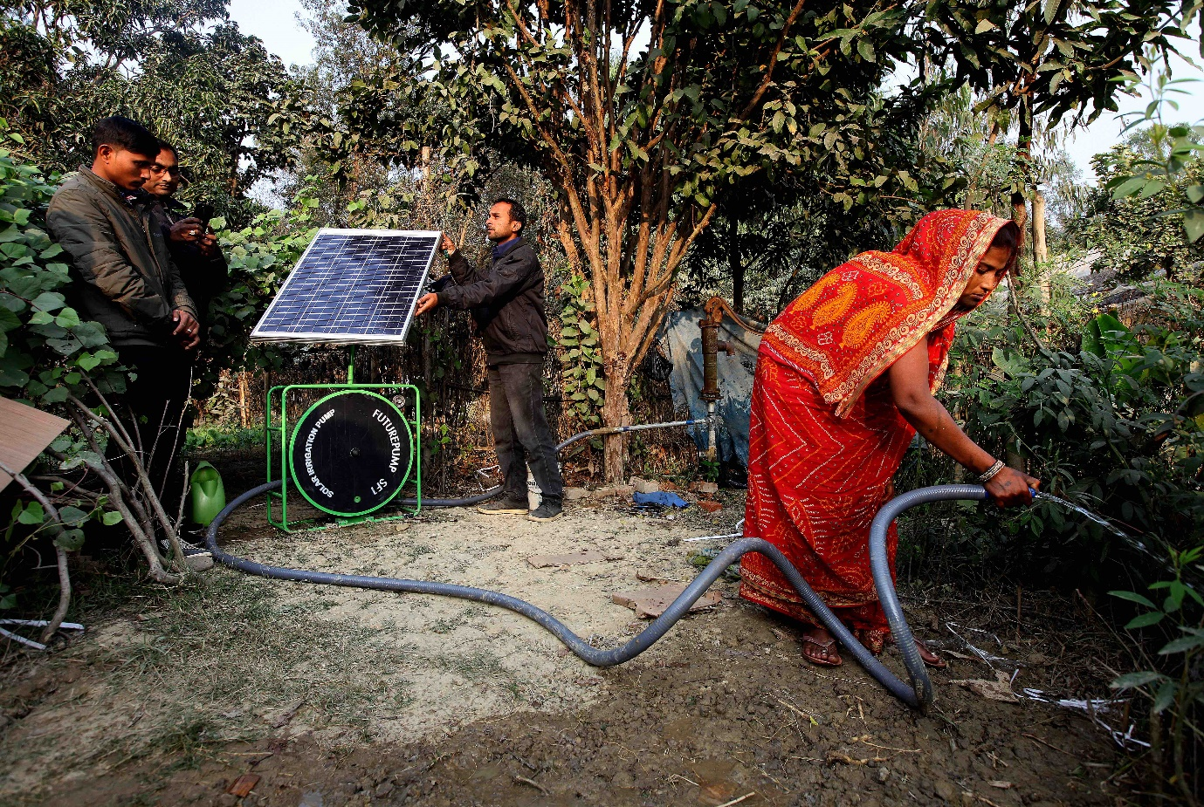According to **Ministry of Environment, Forest and Climate Change**, Government of India, a programme named ‘**National Action Plan for Climate Change’ (NAPCC)** is launched in the year 2008 to mitigate and adapt to adverse impacts of climate change. In the latest updated NAPCC (updated in 2021) The principles and the approach of the NAPCC is quite clear on how to deal with the climate change.[9]

**PRINCIPLES of NAPCC**

Maintaining a high growth rate is essential for increasing living standards of the vast majority of our people and reducing their vulnerability to the impacts of the climate change. In order to develop a sustainable development path that simultaneously advances economic and environmental objectives, the NAPCC have following principles:

* Providing protection for the weaker and poorer segments of society through a strategy for inclusive, sustainable development that is climate change-aware*.*
* Achieving national growth goals through a qualitative change in course that improves ecological sustainability and results in greater greenhouse gas emission reduction.
* Devising efficient and cost-effective strategies for end use demand side management.
* Widespread and rapid adoption of technology that are appropriate for both adaptation and mitigation of greenhouse gas emissions.
* Engineering a new and innovative forms of market, regulatory and voluntary mechanisms to promote sustainable development.
* Effecting implementations of programmes through unique linkages, including with civil society and local government institutions and through public-private-partnership.
* Supporting international collaboration in research, development, sharing, and technology transfer that is made possible by greater funding and a worldwide IPR regime that enables technology transfer to developing nations in accordance with the UNFCCC.

**CURRENT STRATEGIES IN ADAPTATION and MITIGAATION: NAPCC**

After the 5th Assessment report of the IPCC, Indian government had started framing adaptation and mitigation programmes and goals to reduce the effects of climate change.[10]

**Some existing adaptation related programmes (updated 2021)**

* Crop improvement: Development of arid-land crops, pest management, and capacity building.
* Drought proofing: Programmes seek to minimize adverse effects of drought, promote economic development and improve socio-economic conditions of resource poor and disadvantaged sections.
* Forestry: The Forest Conservation Act of 1980 aimed to protect forests and ensure centralized control of rights to use forest land. An aggressive afforestation and sustainable forest management programme has resulted in an increase in carbon stocks to 9-10 gigatons of carbon over the last 20 years.
* Water: In order to improve the amount of available water, the National Water Policy of 2002 suggests unconventional water consumption strategies, such as inter-basin transfers and rainwater collecting. Water harvesting programmes are now required in many jurisdictions.
* Coastal regions: Limitations have been put in place to safeguard coastal ecosystems and allay the worries of the local populace.
* Health: Programmes include human resources, emergency medical assistance, and surveillance and control of vector-borne diseases.
* Risk finance. Crop insurance plans and credit assistance mechanisms are two risk-funding programmes that aid in coping with the effects of climate change.
* Disaster relief efforts are managed by the National Disaster Management Programme, which also offers subsidies to those who have been affected by weather-related disasters. Additionally, it promotes proactive disaster avoidance measures, such as information sharing and personnel training

**India’s actions relating to GHG Mitigation**

India has a thorough legislative, regulatory, and policy framework in place with a strong connection to GHG mitigation:

* Aiming to increase energy efficiency across all industries
* Accelerated development of nuclear and hydropower for clean energy; emphasis on renewables, particularly biofuel plantations; and concentrated R&D on a number of clean energy-related technologies
* A number of additional sections deal with reshaping the energy market to guarantee that it is competitive and that energy prices accurately reflect the costs of the resources.
* These include the Petroleum & Natural Gas Regulatory Board Act of 2006, the Electricity Act of 2005, the Tariff Policy of 2003, and others. When combined, the laws are intended to:
* Lower entry barriers and increase competition in the exploration, extraction, conversion, transmission, and distribution of primary and secondary energy; • Achieve price reform through complete competition at the point of sale.
* Advocate for tax reform to encourage sensible fuel selections.
* Expand and diversify the range of available energy options, sources, and infrastructure.
* Strengthen and, where appropriate, adopt independent regulation. Provide feed-in tariffs for renewable energy sources (solar, wind, biomass cogeneration).

**INTRODUCTION OF LABELLING PROGRAMME FOR APPLIANCES**

The Bureau of Energy Efficiency has made it mandatory for refrigerators and air conditioners to display energy efficiency labels, leading to significant savings in electricity.

**ENERGY CONSERVATION BUILDING CODE**

The Energy Conservation Building Code (ECBC) was launched in 2007, aiming to reduce energy consumption in commercial buildings by 30%-40%. Compliance with the Code is voluntary, but expected to become mandatory soon.

**ENERGY AUDITS OF LARGE INDUSTRIAL CONSUMERS**

In March 2007 the conduct of energy audits was made mandatory in large energy-consuming units in nine industrial sectors. These units, notified as "designated consumers" are also required to employ" certified energy managers", and report energy consumption and energy conservation data annually.

**MASS TRANSPORT**

The National Urban Transport Policy emphasizes public transport and non-motorized modes over personal vehicles, and Maharashtra is imposing a congestion tax to discourage private car use.

**CLEAN AIR INITIATIVES**

Steps to reduce air pollution in urban areas include CNG, retiring old vehicles, strengthening mass transportation, subsidizing electric vehicles, and closing or transferring polluting industrial units.

**PROMOTION OF ENERGY SAVING DEVICES**

The ‘Bachat Lamp Yojana’ encourages households to switch incandescent lamps for CFLs using CDM credits.

**PROMOTION OF BIOFUELS**

The Biodiesel Purchase Policy mandates biodiesel procurement by the petroleum industry. A mandate on Ethanol Blending of Gasoline requires 5% blending of ethanol with gasoline from 1St January, 2003, in 9 States and 4 Union Territories.

On this note **UNDP** shares the updated **NDC** (updated in August 2022). They key highlights and goals are:

* India has committed to reducing emissions intensity of its GDP by 45% by 2030.
* The updated NDC marks an important step towards achieving India’s long-term goal of reaching net-zero emissions by 2070.
* A new framework for transition to cleaner energy for the period 2021-2030 aims to increase green jobs, boost manufacturing of low emissions products such as Electric Vehicles and super-efficient appliances, and promote innovative technologies such as green hydrogen.
* The country committed to stronger adaptation targets. It will enhance investments in development programmes focused on sectors and areas vulnerable to climate change, particularly agriculture, water resources, health, disaster management, the Himalayas, and coastal regions.
* India will build capacities for quick diffusion of cutting-edge climate technology.

On the account of this ‘**our world data**’ have provided us with all the world data of total Co2 and GHG and temperature changes due to them, which can be analysed as **a representation of how the measures of adaptation and mitigation in India are working** [11], [12]

**Data website**: [CO₂ and Greenhouse Gas Emissions - Our World in Data](https://ourworldindata.org/co2-and-greenhouse-gas-emissions)

**Data on git**: [owid/co2-data: Data on CO2 and greenhouse gas emissions by Our World in Data (github.com)](https://github.com/owid/co2-data)

**Data analysis**: [Profile - venkata.sri.satya.gayathri.jonnalagadda | Tableau Public](https://public.tableau.com/app/profile/venkata.sri.satya.gayathri.jonnalagadda)

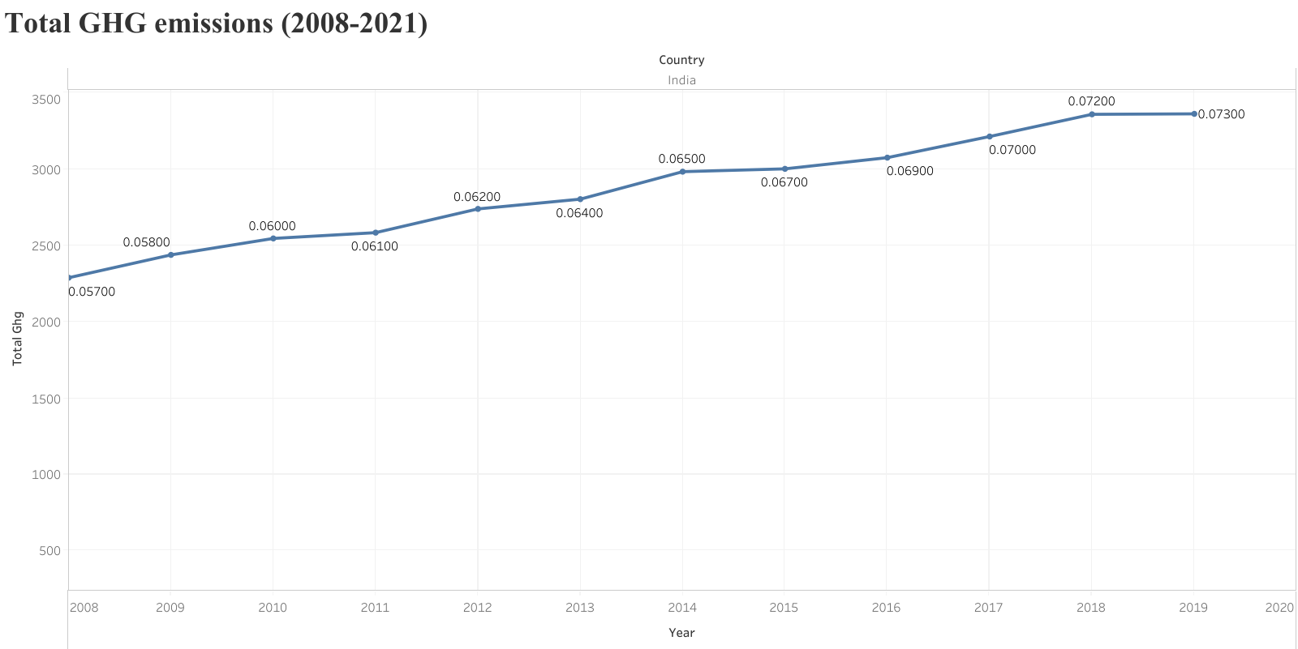Analysis of **total GHG and Co2 variations against temperature change** from the years 2008 to 2020.

*Figure 10 Total GHG emissions against temperature changes (2008-2020), data from ‘*[*our world data’*](CO₂%20and%20Greenhouse%20Gas%20Emissions%20-%20Our%20World%20in%20Data)

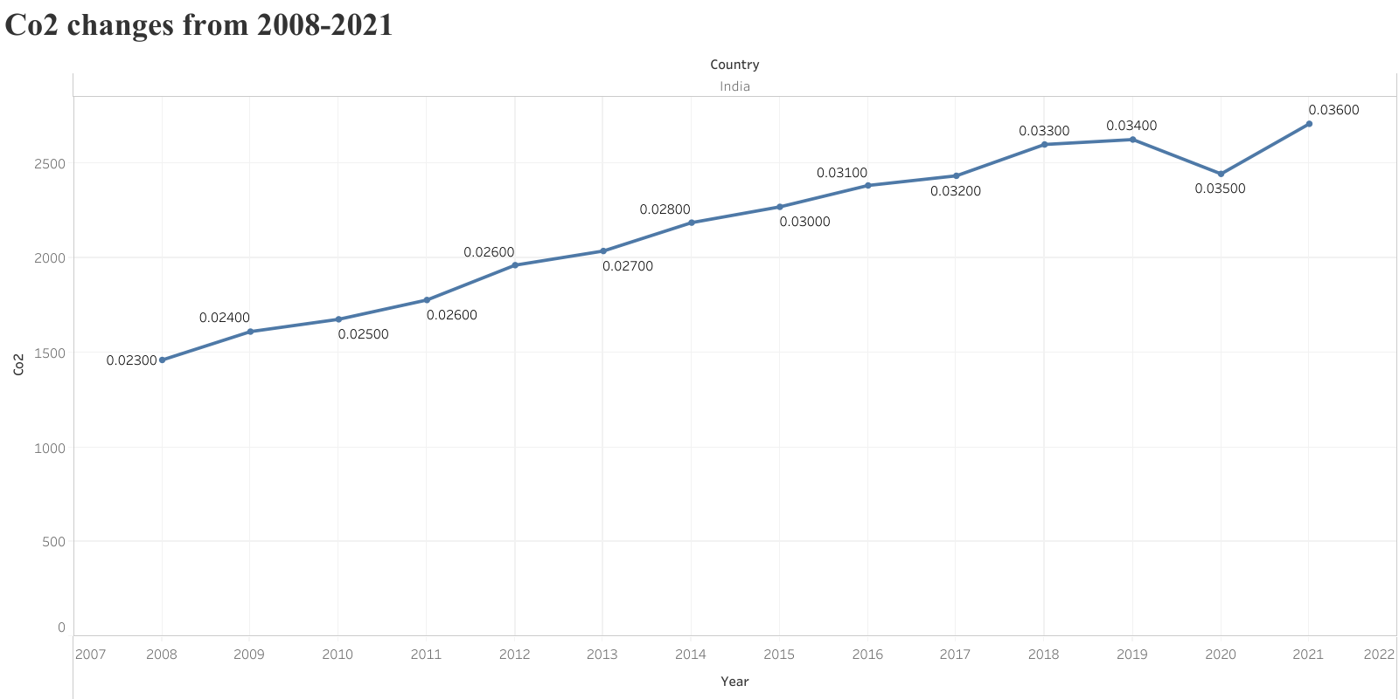

Figure 11 Total co2 emissions against temperature change(2008-2020), dataset: ‘[our world data’](CO₂%20and%20Greenhouse%20Gas%20Emissions%20-%20Our%20World%20in%20Data)

# TOOLS EXPLORED FOR TEXT MINING, ANALYSIS AND VISUALIZATION OF IPCC REPORTS

The IPCC reports are selected as a main source of the information that is being analysed by our team semantic climate in a structured manner to extract all the necessary data which can be turned into a climate-related knowledge base for the world.

Each member of the team works with an individual chapter to extract, analyse and present all the data within the chapter along with any case studies carried out to understand it better.

Also, one of the main goals of the team #SemanticClimate is to develop and optimize a software/tool that can deal with the large scientific literature that is available only in the form of PDFs like the IPCC reports.

TDM TOOLS:

1. Chapter PDF to HTML conversion- Py4ami 0.0.46 (being developed)
2. Keyword extraction – python-Gensim, Rake, Yake
3. Docanalysis (along with annotation)
4. Word cloud generator – online AI, python
5. Voyant Tools 2.0
6. VOS viewer
7. Knowledge graphs – obedient, python- pyvis package

## Py4ami 0.0.46

This tool py4ami 0.0.46 is a semantic reader of the scientific literature [9]. Py4ami is being developed as a client-side tool and its Python framework reads the scientific literature in bulk, transforms it, searches and analyses the contents of the literature, and produces structured information as an output along with converted HTML file of the literature PDF.

**FEATURES/ SCOPE OF Py4ami 0.0.46**

* pyami can collect documents (of any sort) into a corpus or CProject.
* pyami has tools for filtering, cleaning, and normalizing a corpus.
* pyami can search this corpus by filenames, file types, document structure, and content which, can include metadata, text, tables, diagrams, math, chemistry, references and (in some cases) citations.
* searching uses words, phrases, dictionaries, and image content (vectors and pixels)
* search results can be transformed, filtered, aggregated, and used for iterative enhancement.

**ARCHITECTURE OF Py4ami 0.0.46**

* downloaded documents (a corpus) are stored on your disk in a folder/directory (a CProject`)
* each document (CTree) in a CProject is a living subtree of many labelled text subsections (text, paragraphs, sentences, phrases, words) and images (png) This is flexible (new types and subdirectories) can be added by users).
* the CTree is held on disk and can be further processed by other programs (e.g., pandas, tesseract (image2text), matplotlib
* a command line supports many operations for searching, and transforming.
* a GUI (ami-GUI) is layered on the command line to help navigation, query building, and visualisation.
* the command line can be used by workflow tools such as Jupyter Notebooks
* The pyami code is packaged as a Python library for use by other tools

**WHY PDF TO HTML**

As our source, the chapters from the IPCC reports are available only in PDF which makes it hard to liberate knowledge. There are more than one disadvantages/ concerns with PDF’s. They are[13][14]:

* PDFs are locked with no style versions.
* PDFs can’t be updated.
* PDF pages doesn’t ‘flow’ to fit the screen (if we are reading a PDF on a mobile, we should scroll through the text).
* PDFs can’t handle the change from US letter size to A4.
* We can’t link a particular section of page through PDFs.
* It is NOT WEB FRIENDLY.
* PDFs are static and non-interactive.
* Data is hard to be accessed from a PDF.

Extracting information from an image in a PDF is much harder and error prone.

**WORKING OF Py4ami 0.0.46**

* Converting pdf to html
* Validating whether the created dictionary is correct or not
* Annotating the dictionary, which means, one can find the word from the dictionary in the generated html file, and then go to the wikidata page for the word, just by clicking on the word.
* GitHub link: <https://github.com/petermr/pyami.git>

PDF to HTML conversion can be visualized at chapter analysis notebook, created by Ananya Singha, Alum, #SemantciClimate

<https://github.com/petermr/semanticClimate/blob/5ba00393451e2b649185290d3ff77b44adc5407a/outreach/climate_knowledge_hunt_hackathon/Hackathon_Notebook/Chapter_Analysis_Notebook.ipynb>

## KEYWORD EXTRACTION

The keyword extraction process helps us in identifying the important words. It also effective in topic modelling tasks. You can know a lot about your text data by only a few keywords. These keywords will help you to determine whether you want to read an article or not.

**PYTHON PACKAGES USED FOR KEYWORD EXTRAXTION** [15]

***Gensim***

Gensim is an open-source library for unsupervised topic modelling, document indexing, retrieval by similarity, and other natural language processing functionalities, using modern statistical machine learning. It is implemented in Python and cython for performance.

Gensim is designed to handle large text collections using data streaming and incremental online algorithms, which differentiates it from most other machine learning software packages that target only in-memory processing.

**RAKE**

**Rapid Automatic Keyword Extraction (RAKE)** is a Domain-Independent keyword extraction algorithm in Natural Language Processing. [16]It is an Individual document-oriented dynamic Information retrieval method. Concept of RAKE is built on three matrices Word Degree (deg(w)), Word Frequency (freq(w)), Ratio of the degree to frequency (deg(w)/freq(w)).

**YAKE**

YAKE is a light-weight unsupervised automatic keyword extraction method which rests on text statistical features extracted from single documents to select the most important keywords of a text. This system does not need to be trained on a particular set of documents, neither it depends on dictionaries, external-corpus, size of the text, language or domain.

The above three packages were incorporated into a single piece of code but does not work at a time, we just have to change the ‘method’ in the code to experiment with each package.

**Code availability**: Git repository (created by Karthikeyan V, Ananya Singha, Alum, #SemanticClimate)

<https://github.com/petermr/semanticClimate/tree/5ba00393451e2b649185290d3ff77b44adc5407a/keyword_extraction/code>

**execution** (chapter analysis notebook) (created by Ananya Singha, Alum, #SemanticClimate)

<https://github.com/petermr/semanticClimate/blob/5ba00393451e2b649185290d3ff77b44adc5407a/outreach/climate_knowledge_hunt_hackathon/Hackathon_Notebook/Chapter_Analysis_Notebook.ipynb>

## DOCANALYSIS

docanalysis is a Command Line Tool that ingests corpora (CProjects) and carries out text-analysis of documents, including

* sectioning
* NLP/text-mining
* dictionary generation

Besides the bespoke code, it uses NLTK and other Python tools for many operations, and spaCy or scispaCy for extraction and annotation of entities. Outputs summary data and word-dictionaries. This software/tool is created by Shwetha N. Hegde, Alum, #SemanticClimate.

GitHub link: <https://github.com/petermr/docanalysis.git>

Docanalysis was run to extract abbreviated data and produce it as an XML file from the selected chapters HTML files.

**ANNOTATING HTML FILE**

The extracted abbreviations were taken as an input and then all those words were annotated in the HTML file (which later will be developed to annotate and connect it to the wikibase).

**Code availability for execution**: chapter analysis notebook (created by Ananya Singha, Alum, #SemanticClimate

<https://github.com/petermr/semanticClimate/blob/5ba00393451e2b649185290d3ff77b44adc5407a/outreach/climate_knowledge_hunt_hackathon/Hackathon_Notebook/Chapter_Analysis_Notebook.ipynb>

## SUMMARIZATION TOOLS

Summarization being a key part of text mining that brings us close to Natural Language Processing. All the summariser tools that were explored were experimented on both the pdf and text formats of the chapter ‘Finance & Investment’ from the IPCC AR6 and also used to scrape the data from the UNDP India website for the data of the most invested sectors, as a part of the case study.

Tools:

* QuillBot summarizer[17]
* IntelliPPT: AI- online summarization tool[18]
* SMMRY[19]

**QuillBot**

QuillBot is an AI(by google) that summarises the text, documents, papers, articles using **Natural Language Processing** to locate useful information in the input and produce both key sentences or a summarized paragraph.

**Tool/software**: [Text Summarizer | QuillBot AI](https://quillbot.com/summarize)

**IntelliPPT: AI-Powered Online Summarization Tool**

Along with providing summarizer for PDF, DOCX and text, this online AI powered tool helps in generating various types of summaries namely abstracts and executive summaries. It not only summarizes but also works as a text simplifier.

Exploration of this tool, helped in understanding the AI and also types of summarizations.

**Tool/software:** [Online Summarization Tool | PDF Summarizer | Summarize articles, text, documents with IntelliPPT](https://www.intellippt.com/)

**SMMRY**

SMMRY (a text summarizer) , provides an efficient manner of understanding text, which is done primarily by reducing the text to only the most important sentences. SMMRY accomplishes its mission by:

* Ranking sentences by importance using its core algorithm.
* Reorganizing the summary to focus on a topic; by selection of a keyword.
* Removing transition phrases.
* Removing unnecessary clauses.

Removing excessive examples**.**

**Tool/software:** [SMMRY - Summarize articles, text, websites, essays and documents](https://smmry.com/)

## WORD CLOUDS

The concept of text mining and visualization also have an interesting part which concentrates only the words- keywords.

The idea of word cloud generation in text mining is a basic, yet very useful method of visualization. A word cloud is a visual representation of the most often used words in a corpus of text. Larger the word appears; higher the word is used in the given input. Word clouds can be particularly helpful when you want to:

* Quickly identify the most important themes or topics in a large body of text
* Understand the overall sentiment or tone of a piece of writing
* Explore patterns or trends in data that contain textual information
* Communicate the key ideas or concepts in a visually engaging way

**TOOLS/SOFTWARE EXPLORED FOR WORD CLOUD GENERATION**

* MonkeyLearn AI word cloud generator
* Word cloud generator using PYTHON

**MonkeyLearn- AI WORD CLOUD GENERATOR**

This tool uses transcription and Natural Language Processing to skim through the unstructured text data given as an input into word clouds.[20]

**Tool :** [Free Word Cloud Generator – MonkeyLearn](https://monkeylearn.com/word-cloud)

**WORD CLOUD GENERATION-PYTHON**

The code in python is written using packages like *word cloud*, *mpl*_*toolkits*, *pyplot* and *pandas.*

This piece of code uses the keywords extracted using gensim to generate a word cloud.

**Code availability and execution**:

<https://github.com/petermr/semanticClimate/blob/5ba00393451e2b649185290d3ff77b44adc5407a/outreach/climate_knowledge_hunt_hackathon/Hackathon_Notebook/Chapter_Analysis_Notebook.ipynb>

## VOYANT TOOLS

Voyant Tools is an open-source, web-based application for performing text analysis. It supports scholarly reading and interpretation of texts or corpus, particularly by scholars in the digital humanities, but also by students and the general public. It can be used to analyse online texts or ones uploaded by users. Voyant Tools was developed by Stéfan Sinclair (McGill) and Geoffrey Rockwell (University of Alberta) and continues to be updated[21], [22]

This is a unique open-source tool that gives the word cloud, inputs summary in terms of number of words, number of new words with many other inbuilt visualization tools and also graphical representation of the frequency of the words in the word cloud. But it automatically skips tables and images in the given PDF/DOCX/URL/text.

**Tool:** [TAPoR (archive.ph)](https://archive.ph/20170329181913/http:/tapor.ca/home)

**Text visualization outputs**: [Voyant Tools (voyant-tools.org)](https://voyant-tools.org/?corpus=b34d6a9a0d8628ab30bc8b8fb4d6be5d), [Voyant Tools (voyant-tools.org)](https://voyant-tools.org/?corpus=2b36a1d41cc070a40c5ff28fd9c1a539)

## VOSviewer

VOSviewer is a software tool for constructing and visualizing bibliometric networks. These networks may for instance include journals, researchers, or individual publications, and they can be constructed based on citation, bibliographic coupling, co-citation, or co-authorship relations. VOSviewer also offers text mining functionality that can be used to construct and visualize co-occurrence networks of important terms extracted from a body of scientific literature.[23]

This tool was experimented to observe the bibliometric network of the “climate related development in India” scraped from the “web of science” as a part of data mining to use it with expanding the knowledge graph of the chapter15 based on the text data.

This tool collects all the words into various clusters and connects it with edges. The output graph represents all the used words in all the literature.

tool: [VOSviewer - Visualizing scientific landscapes](https://www.vosviewer.com/), (install the tool to work on it)

source of corpus: [climate related development in India (All Fields) – 1,588 – Web of Science Core Collection](https://www.webofscience.com/wos/woscc/summary/59258e1d-e864-4b01-aa5d-e79d1e4f2d8b-892fdee3/relevance/1)

## KNOWLEDGE GRAPHS

A knowledge graph, also known as a semantic network, represents a network of real-world entities—i.e., objects, events, situations, or concepts—and illustrates the relationship between them. This information is usually stored in a graph database and visualized as a graph structure, prompting the term knowledge “graph.” A knowledge graph is made up of three main components: nodes, edges, and labels.[24]

Knowledge graphs, that are fuelled by machine learning, utilize natural language processing (NLP) to construct a comprehensive view of nodes, edges, and labels through a process called semantic enrichment. When data is ingested, this process allows knowledge graphs to identify individual objects and understand the relationships between different objects. This working knowledge is then compared and integrated with other datasets, which are relevant and similar in nature. Once a knowledge graph is complete, it allows question answering and search systems to retrieve and reuse comprehensive answers to given queries.

Building knowledge graphs for the IPCC reports with the support of **wikibase** is the ultimate goal, where in all the keywords/phrases are brought out in a graph along with the data, sections, images and tables that are related with it inside that particular literature and also from the wiki data.

Exploration of various graph making tools helps us to draw a prototype which states how our final output of the working of the software is supposed to work.

**TOOLS EXPLORED TO BUILD KNOWLEDGE GRAPH**

* Obsidian
* KG- Python (developing)

**OBSIDIAN**

Obsidian is a note making app that works on a markup language. It was captioned as a second brain as it helps the user to make a flow of his knowledge and connect them easily. It is a do-it-yourself app, where we manually add all the data into various nodes as per our choice and then connect them using links and tags.[25]

Making a knowledge graph in obsidian gives an idea on how nodes, edges and links work and helps us experience how simplified a graphical view of the data looks to dive into.

**tool/software/app**: [Obsidian](https://obsidian.md/)

**KNOWLEDGE GRAPH DEVELOPMENT USING PYTHON**

With the understanding of how knowledge graph works, a piece of code from the pyami software,test_html.py,*test_extract_ipcc_nodes_and_pointers_raw_format_NODES_CURRENT* (developed by Dr Peter Murray-Rust), extracts all the links from the chapter 15 HTML file and saves it as an xml file. These links are then manually modified as the sources and targets to develop a knowledge graph (code developed by Shwetha N. Hegde).

However, it’s still in the developing stage and the links produced by the codes comes with unknown id’s which acts as the source but are actually unknown. There is still a lot of writing, testing and debugging which also includes wikibase to link the data out of the chapter with the wikidata ID’s.

**Code availability:**

**LINKS EXTRACTION**

<https://github.com/petermr/pyami/blob/3a7f3943b6b34cc2ef1288bc487a18f7fbbd4608/test/test_html.py>

**KNOWLEDGE GRAPH VISUALIZATION**

**Code developed by Shwetha N. Hegde**

<https://github.com/petermr/semanticClimate/tree/5ba00393451e2b649185290d3ff77b44adc5407a/ipcc/ar6/wg3/Chapter15/Knowledge_graph>

# RESULTS and ANALYSIS OF TDM TOOLS

The best way to report a result is to divide it into:

* Why I did, what I did?
* What I did? (experiment)
* How I did? (Input methods)
* Output/results and analysis

## Py4ami 0.0.46

The software py4ami is a python framework that is being developed to focus on PDFs into HTML conversion and analysing that data. Pyami from py4ami specifically does the PDF to HTML conversion.

**Observations**:

* The **input file for the code is a raw PDF file**
* **Input fine on GitHub**.

<https://github.com/petermr/semanticClimate/blob/5ba00393451e2b649185290d3ff77b44adc5407a/ipcc/ar6/wg3/Chapter15/fulltext.pdf>

* The code automatically skips tables and images (for now).
* The **PDF gets converted into HTML file.**
* **Output file on GitHub**

<https://github.com/petermr/semanticClimate/blob/5ba00393451e2b649185290d3ff77b44adc5407a/ipcc/ar6/wg3/Chapter15/fulltext.html>

* Removal of unwanted footnotes, notes, watermarks and headings etc

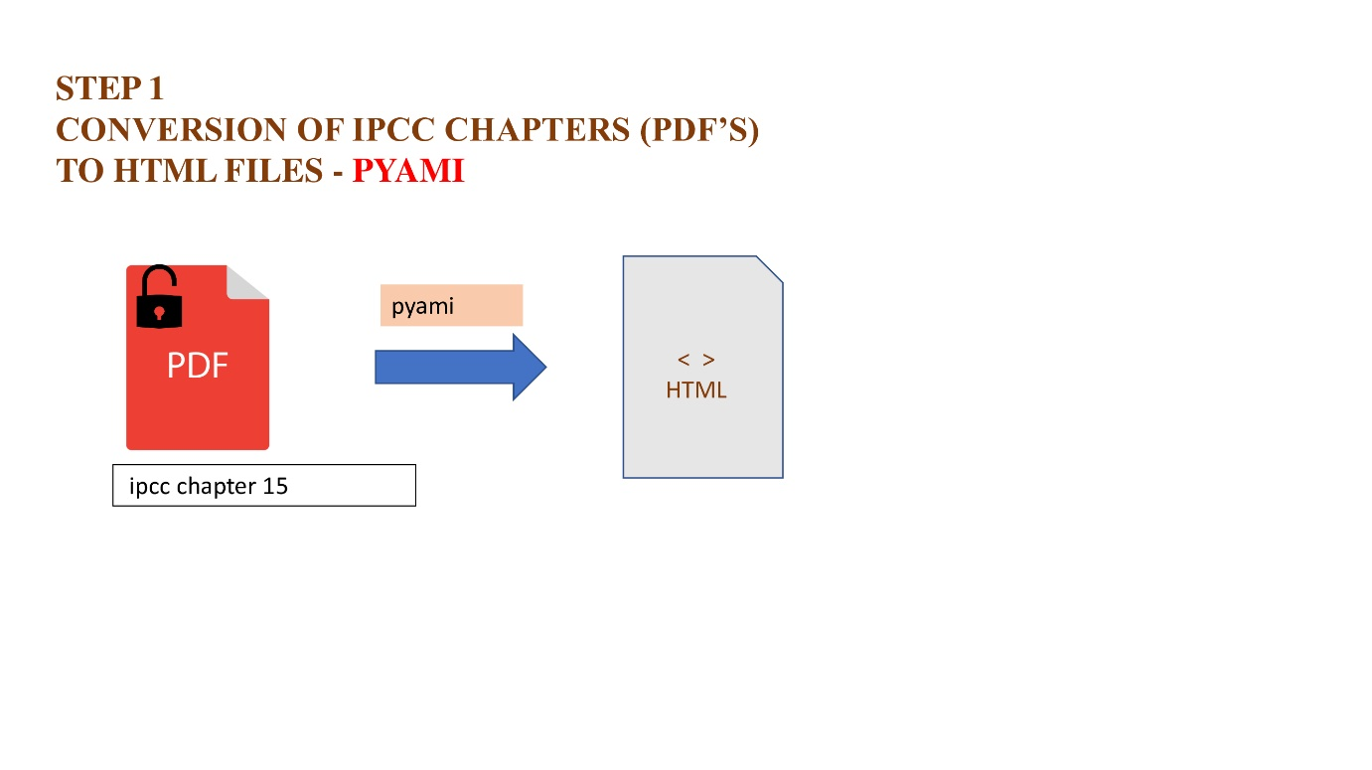.

Figure 12 Representation of working of pyami

**Results**

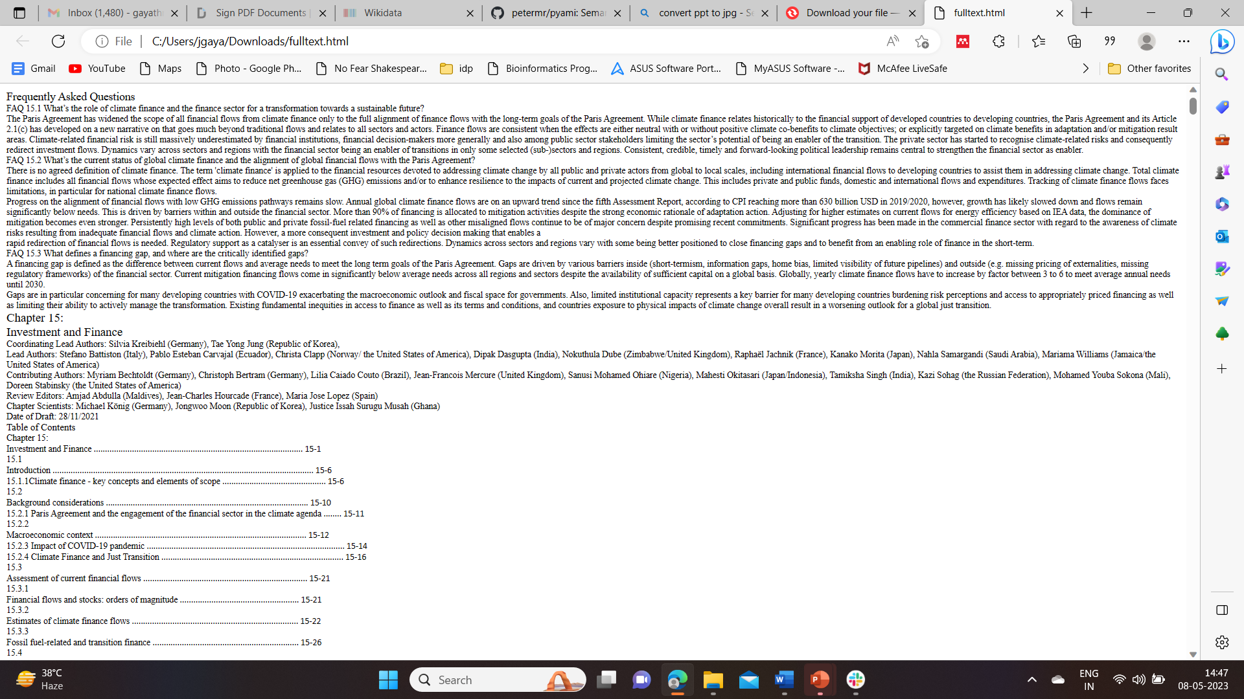The PDF of the chapter is converted into HTML

Figure 13 First page of the chapter’s HTML file on [GitHub](https://github.com/petermr/semanticClimate/blob/5ba00393451e2b649185290d3ff77b44adc5407a/ipcc/ar6/wg3/Chapter15/fulltext.html)

**Analysis**

The conversion of PDF files into HTML makes it both human and machine readable, which makes further automation, extraction of text data simpler.

## KEYWORD EXTRACTION

**Corticol.io (non python)**

**Observations:**

* Trying an open-source AI tool called corticol.io gave a perspective of ‘what can be the keywords?’
* It’s a simple tool, where the input can be a text, PDF, DOCX, or an URL.
* It works on NLP and picks out the words that are more used.
* This tool is experimented with various text, pdf, URL data.
* Below represented one example and results of the experiment.

**KEYWORD EXTRACTION USING PYTHON**

The packages ‘gensim’, ‘RAKE’ and ‘YAKE’ are experimented on the IPCC chapter ‘Finance and Investment’ as a part of Py4ami software.

**Observations:**

* Requires the **HTML file of the chapter** as input
* These packages also use NLTK (Natural Language Tool Kit) to detect the keywords.
* These extracted keywords can be used to develop word clouds (text visualization)
* Can be made into a dictionary, that can later be connected to a wikibase.

**Results:**

Results of the open-source AI, corticol.io

**Analysis:**

This tool is explored to learn the pattern of detection of the keywords, but doesn’t give promising results.

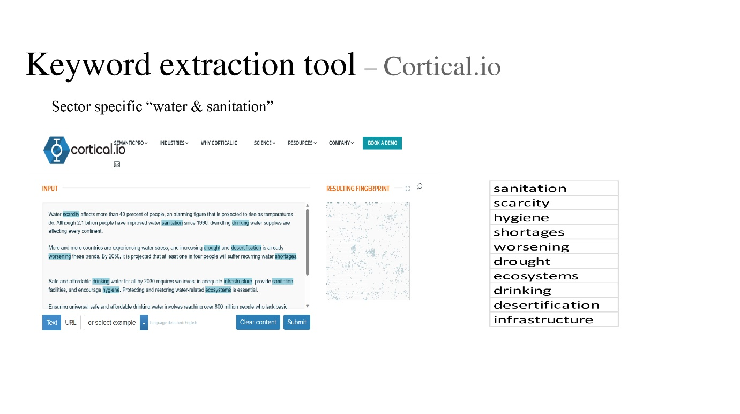

Figure 14 Keyword extraction tool performed on various data (one example)

**Results of Keyword extraction, using python packages**

**Analysis:**

The packages, genism, RAKE and YAKE, gives better results of keywords. The feature called N-gram helps us to increase the count of words that can be extracted, making it further available and easier to extract key phrases too. The scores represent how often the word is used, higher the score, the more important it is.

**Genism result dataset**: CSV file on git

<https://github.com/petermr/semanticClimate/blob/e0794abeef8d7ecf0a6693717b673eec0399450f/ipcc/ar6/wg3/Chapter15/gensim_keywords.csv>

**RAKE result dataset**: CSV file on GitHub

<https://github.com/petermr/semanticClimate/blob/e0794abeef8d7ecf0a6693717b673eec0399450f/ipcc/ar6/wg3/Chapter15/Rake_keywords.csv>

**YAKE result dataset**: CSV file on GitHub

<https://github.com/petermr/semanticClimate/blob/e0794abeef8d7ecf0a6693717b673eec0399450f/ipcc/ar6/wg3/Chapter15/yake_keywords.csv>

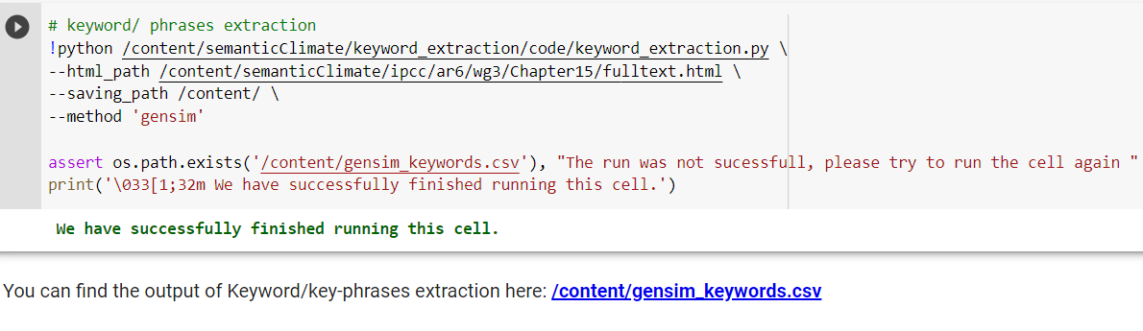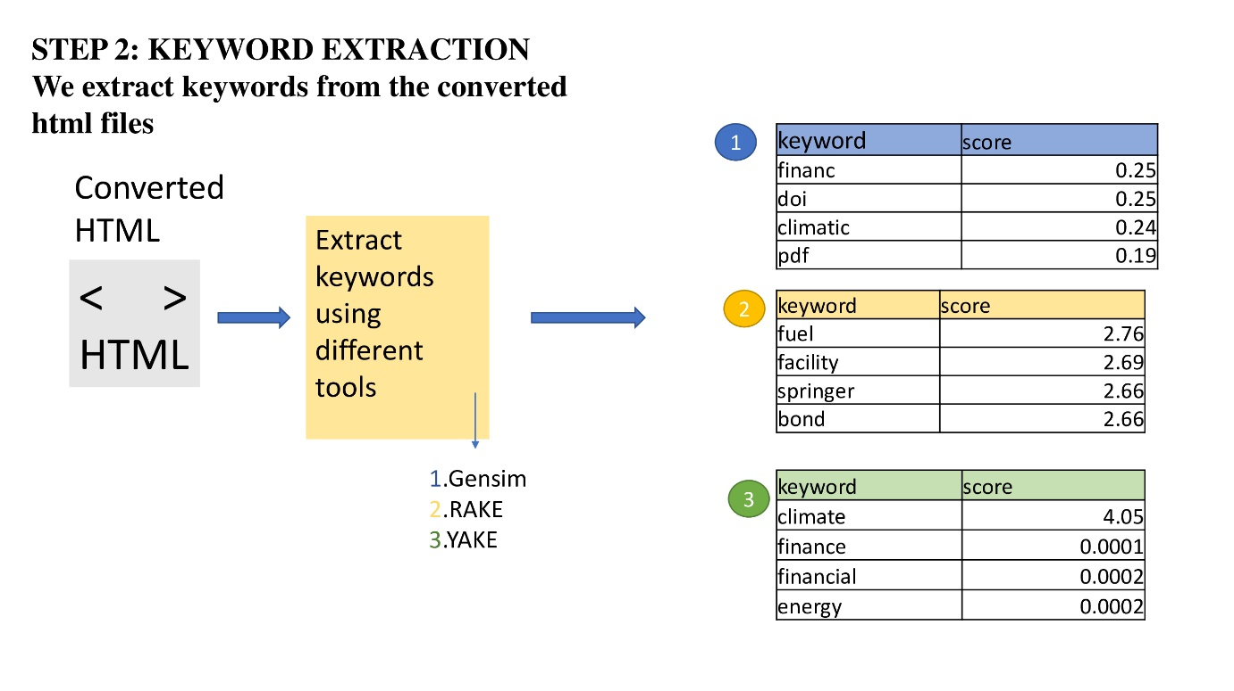

Figure 15 Python code for keyword extraction (Google colab)

Figure 16 Representation and results of Keyword extraction using Python

## DOCANALYSIS

*Docanalysis* is a piece of code that extracts abbreviated words from the input HTML file.

**Observations:**

* Docanalysis also requires **HTNL /XML file as an input**.
* The output abbreviations are automatically stored in an excel file.

Output CSV file on GitHub

<https://github.com/petermr/semanticClimate/blob/e0794abeef8d7ecf0a6693717b673eec0399450f/ipcc/ar6/wg3/Chapter15/abbreviation.csv>

* Sometimes the abbreviations extracted are repeated and should be discarded manually.

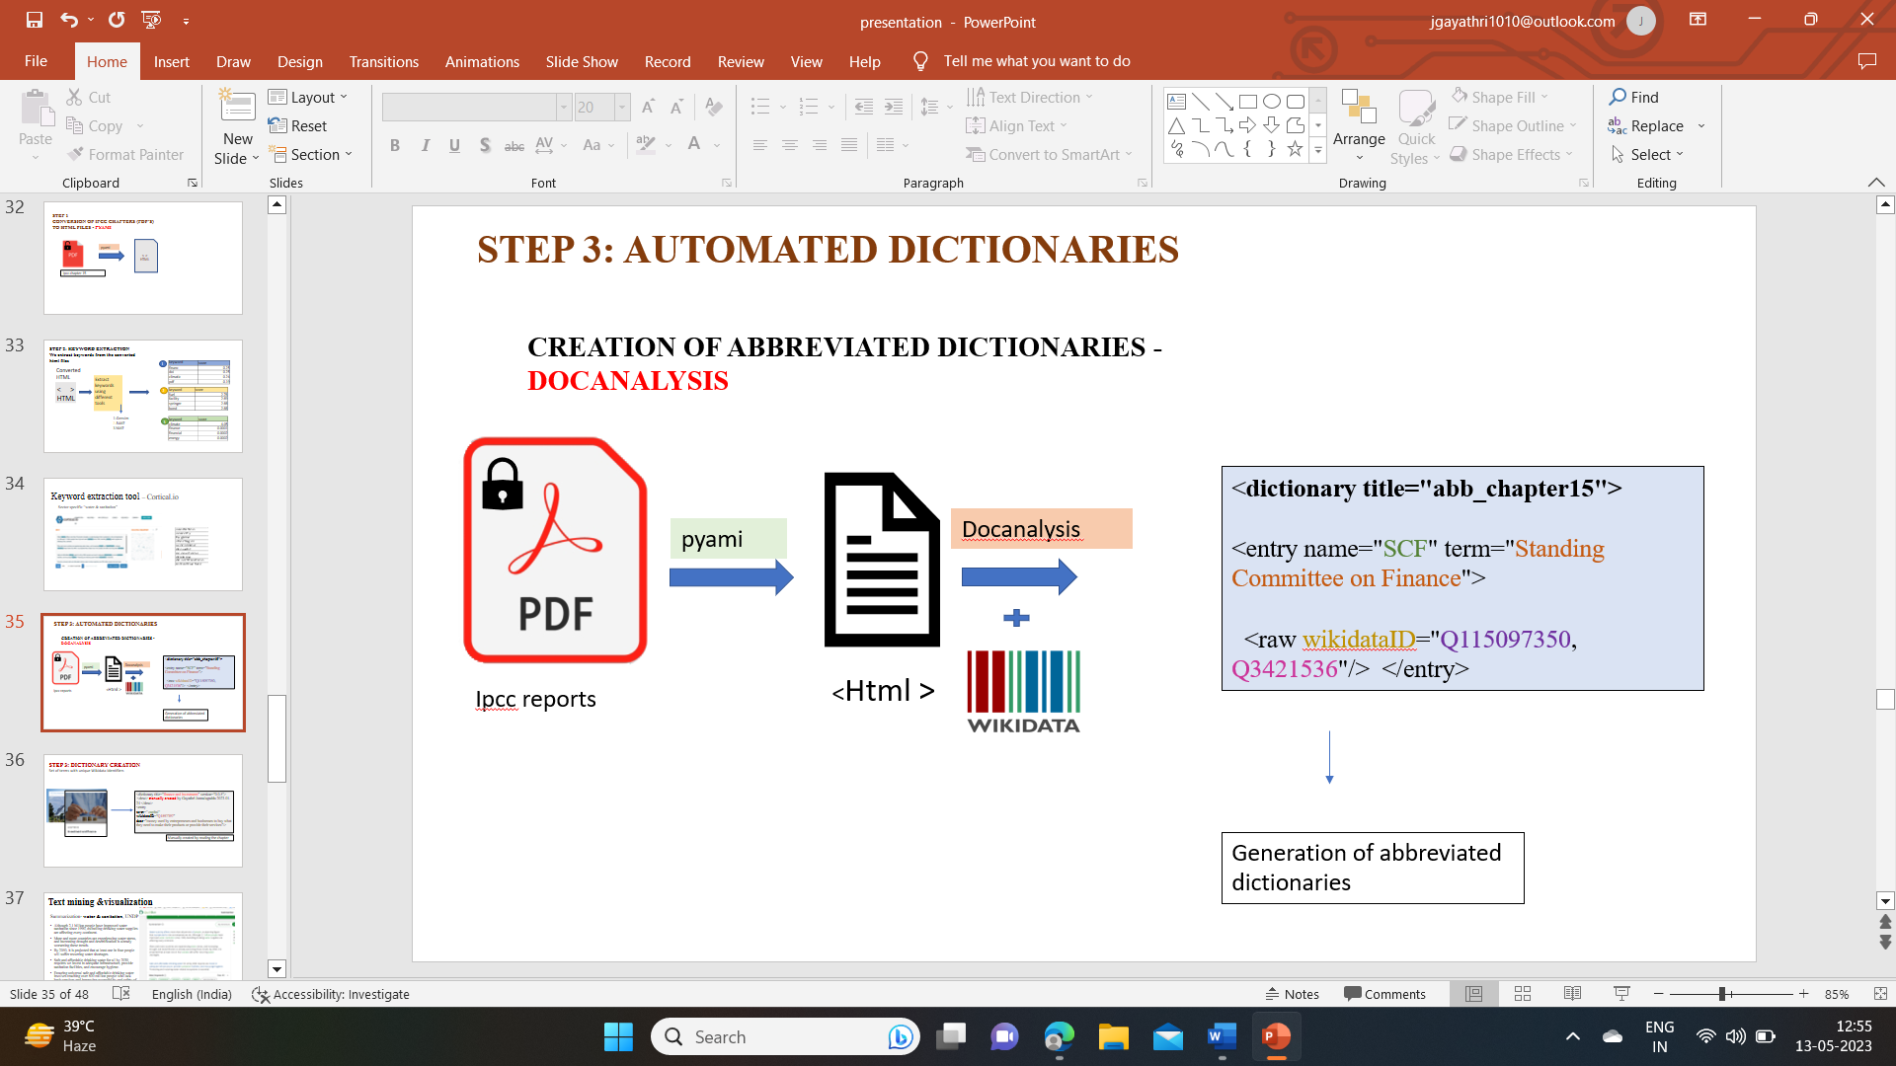**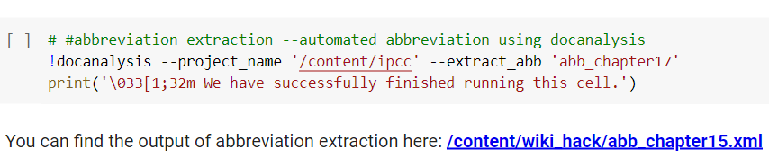Results**

Figure 17 Representation of working and output of docanalysis

Figure 18 Python code for docanalysis(by Shwetha N. Hegde, Alum, #SemanticClimate)

**Analysis:**

The docanalysis results are used to annotate the HTML file, which will later be linked with wikidata id’s of a particular keyword/phrase.

**DICTIONARIES**

Along with the automated abbreviated dictionary, a manual dictionary, which is collection of words/phrases that are hard to understand and are not picked up by the tools, made in XML format, which can be compared with the results of keyword/phrase and abbreviation tools to make a dictionary of climate related terms specific to the chapter.

### 

Figure 19 Manual creation of a Dictionary

### Annotating the HTML file

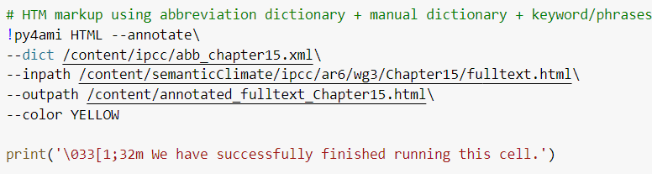Annotating the HTML file on the basis of extracted abbreviations is done. Linking those terms to their wikidata id’s is a future prospect.

Figure 20 Python code for annotating HTML file (developed by Ananya Singha, Alum, #SemanticClimate)

**Results**

**Example annotated abbreviation: ECB –** European Central Bank.

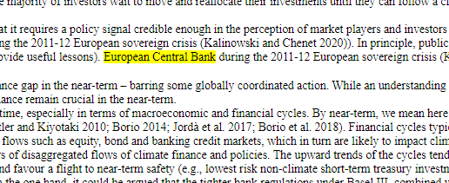

## SUMMARIZATION TOOLS

**Observations:**

* Input text data: Data from
* The summarization tools explored gives out a good response, but differs with large documents or PDF’s that can have thousands of pages.
* Most of the tools, have a limit to the number of input words, number of keywords to select, using which the summary is generated.
* The summarization tool, that is being developed by our team #SenmanticClimate will have all the features, that are required to generate summary for largest PDF’s.

**Results:**

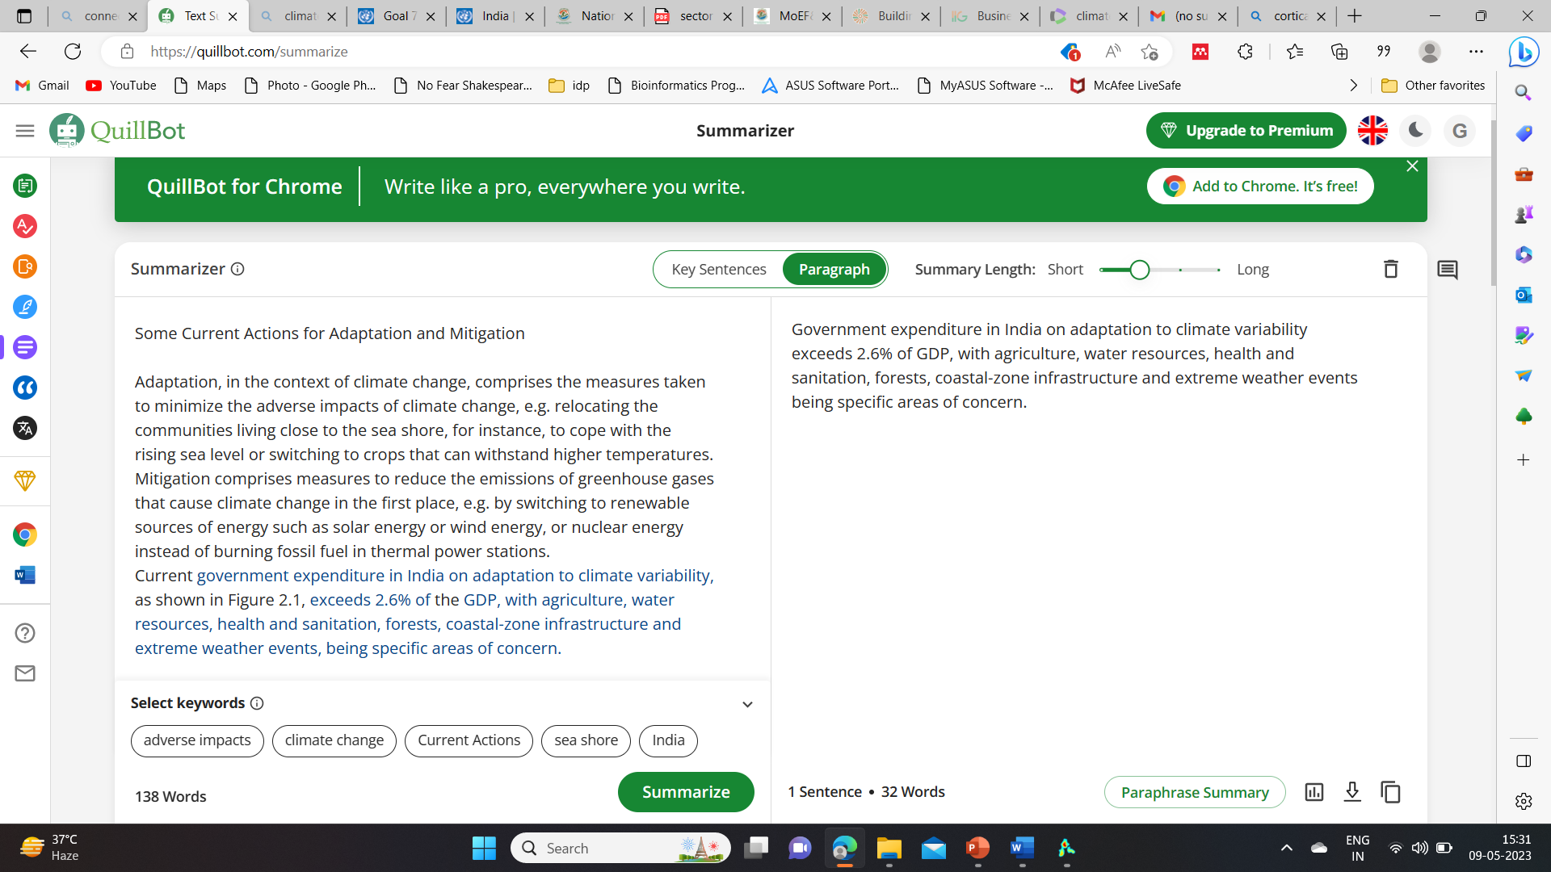**Quill Bot, intelliPPT, SMMRY** summarizers experimented on [case study data](National%20Action%20Plan%20on%20Climate%20Change%20|%20The%20Official%20Website%20of%20Ministry%20of%20Environment,%20Forest%20and%20Climate%20Change,%20Government%20of%20India%20(moef.gov.in))

Figure 21 Quill Bot summariser working on adaptation and mitigation measures (case study)

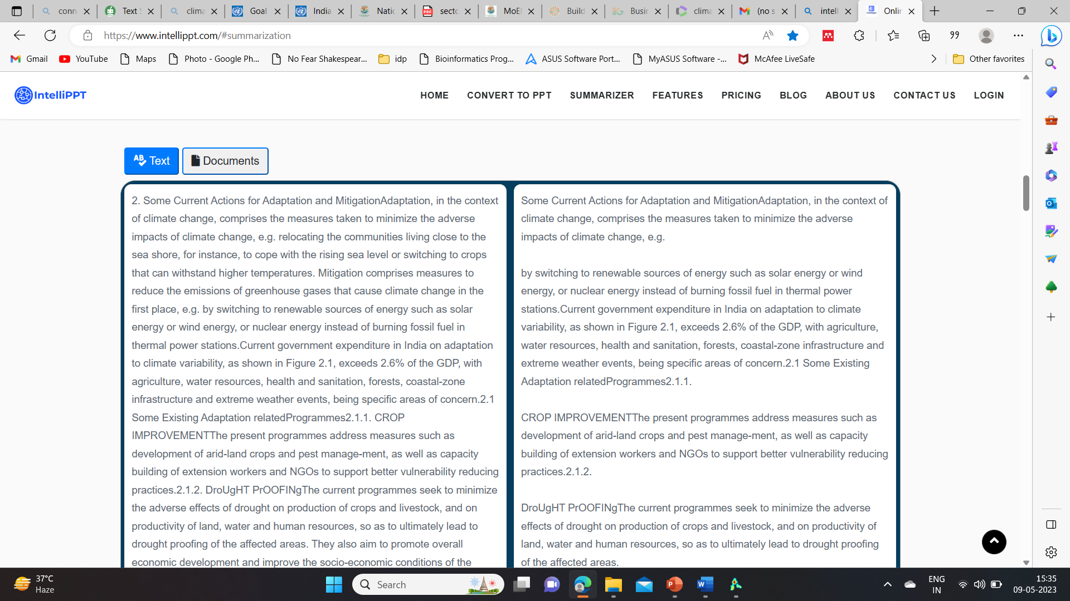

Figure 22 IntelliPPT summariser working on case study data

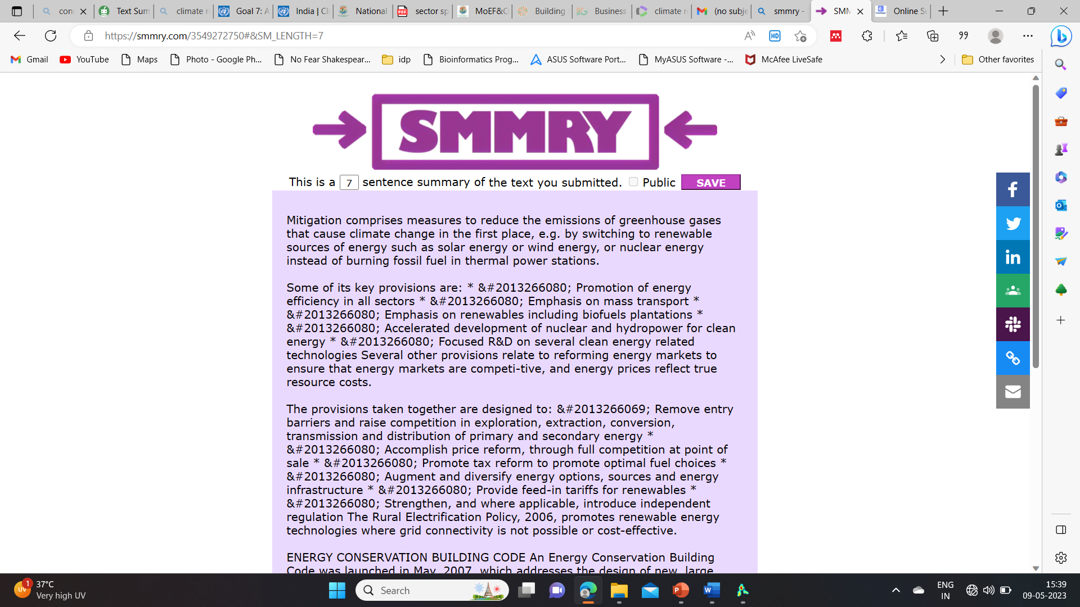**Analysis of tools**:

Figure 23 SMMRY summarizer working on case study data

The tools explored for summarisation were good to work with simple text data, but not suitable for scientific literature. This is solely an experiment to test the tools, with scientific literature data. None of the above explored tools have features to deal with large PDF data.

## WORD CLOUDS

Text mining methods allow us to highlight the most frequently used keywords in a paragraph of texts. One can create a word cloud, also referred as text cloud or tag cloud, which is a visual representation of text data.

Observations:

* The tool MonkeyLearn AI used for generating word clouds, works only with text files.
* The python code to develop word clouds only works when we give it a set of keywords in xml format.

**Results:**

MonkeLearn AI

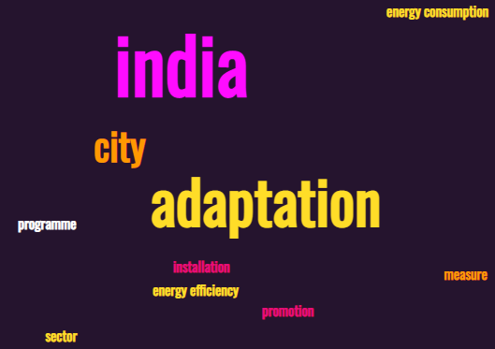

Figure 24 Word cloud developed using MonkeyLearn

Python code to generate word cloud 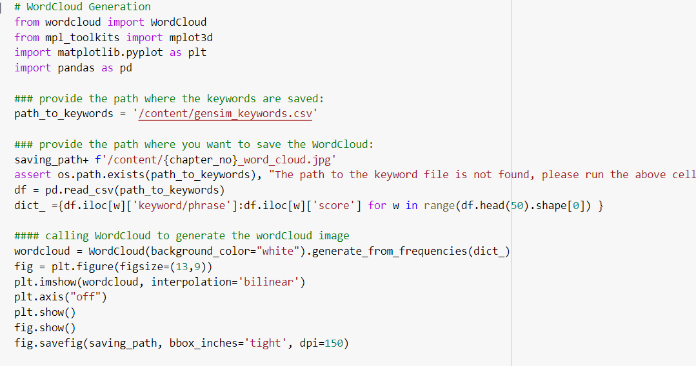

Figure 25 Python code for Word cloud generation,( developed by Ananya Singha, Alum, #SemanticClimate)

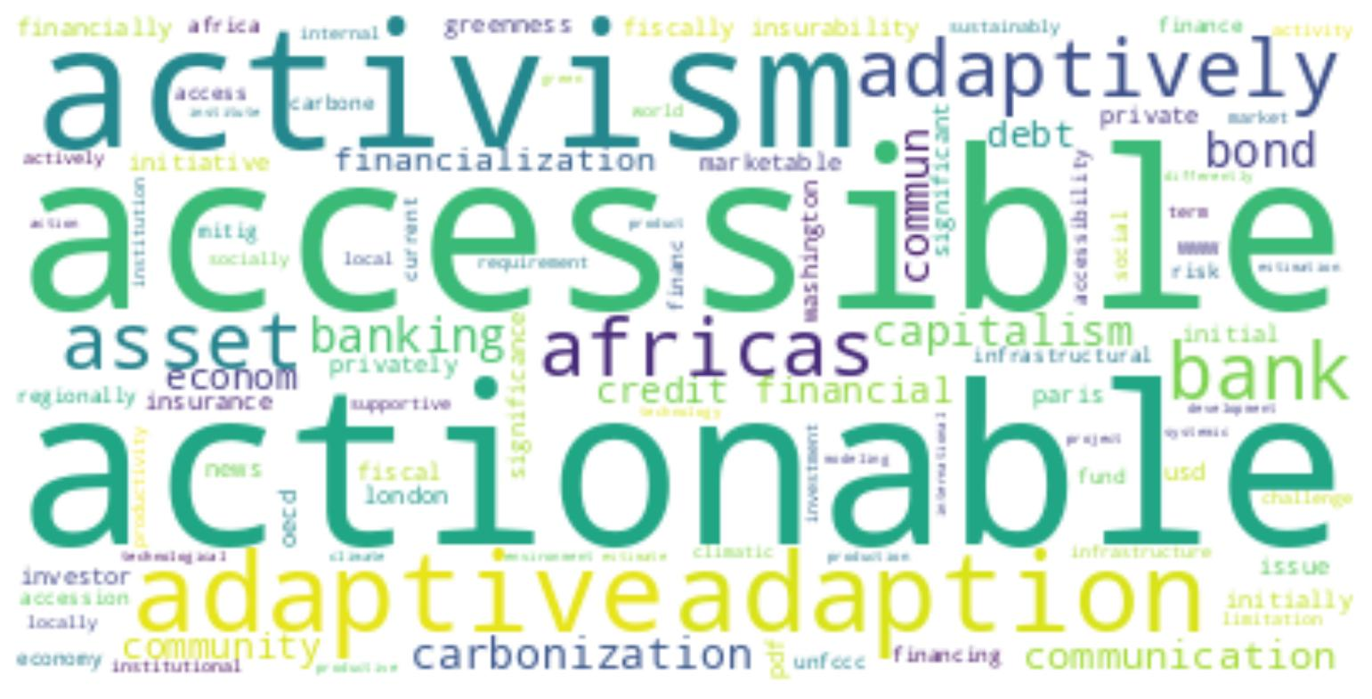 **Analysis**:

Figure 26 Word cloud from chapter 'Finance & Investment'

The AI tool explored to generate word cloud gives only those words that are repeated maximum times in the given text (out of context words, for e.g.: ‘install’).

Whereas, the word cloud generated using python, takes the input file of genism-extracted keywords, which is better to visualize the text to understand the context of the text data.

## Voyant Tools

**Observations:**

* This text analysis portal was a great way to analyse text data, in any of the file format.
* The output visualization will be phrases, thematic summary, total word count and graphs related to it.
* **Text visualization outputs**: [Voyant Tools (voyant-tools.org)](https://voyant-tools.org/?corpus=b34d6a9a0d8628ab30bc8b8fb4d6be5d), [Voyant Tools (voyant-tools.org)](https://voyant-tools.org/?corpus=2b36a1d41cc070a40c5ff28fd9c1a539)

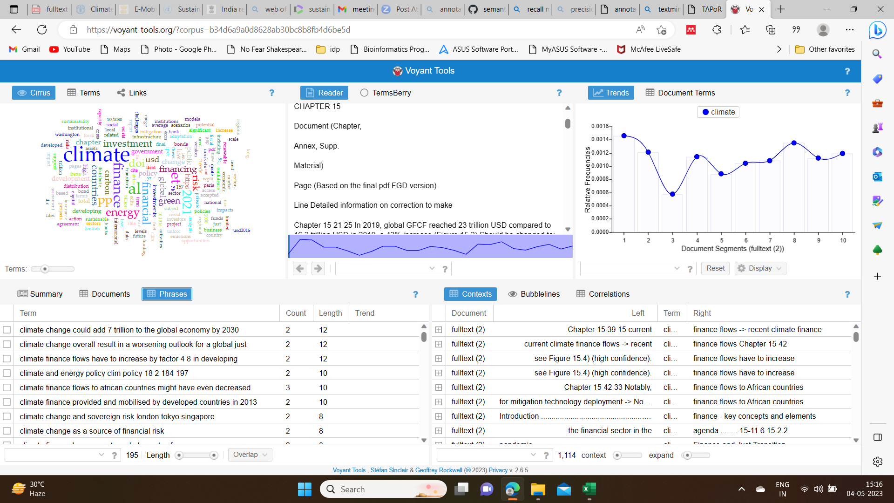**Result**

Figure 27 Text Visualization using voyant tools

**Analysis:**

The corpus voyant tools, provides the user with various text analysing and visualization tools, that can be changed instantly and view the results immediately. These corpus tools are so far the best open source, available for textual analysis. However, the output screen of this tool doesn’t allow the user to either download the data or view it individually.

## Vos Viewer

Exploration of this science mapping tool gave insights about the clustering of the text data and connecting them.

**Observations:**

* The tool accepts data as plain texts only from the databases like Web of Science.
* It is easy to visualise.
* Provides three types of visualizations: Density visualization, Overlay visualization and Network visualization.

**Results:** experimented with data of “**Climate related development in India**” from Web of Science.

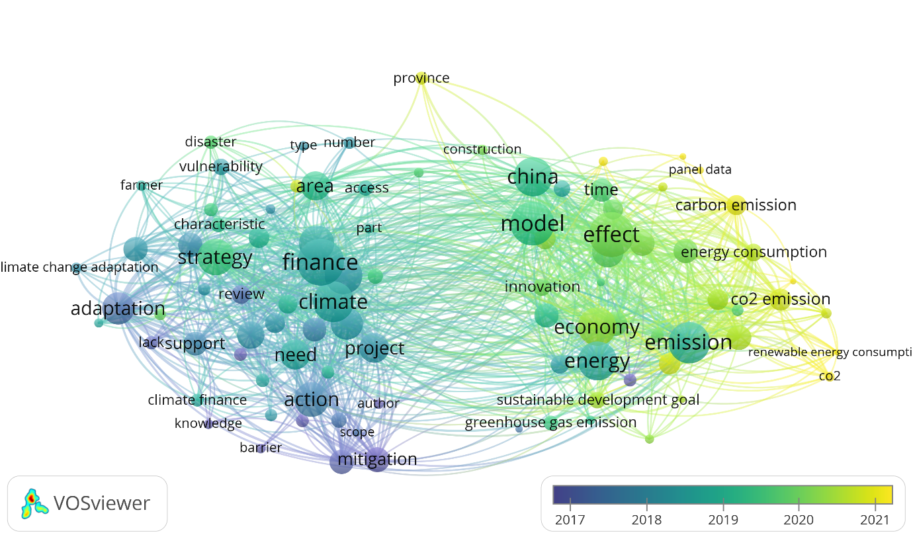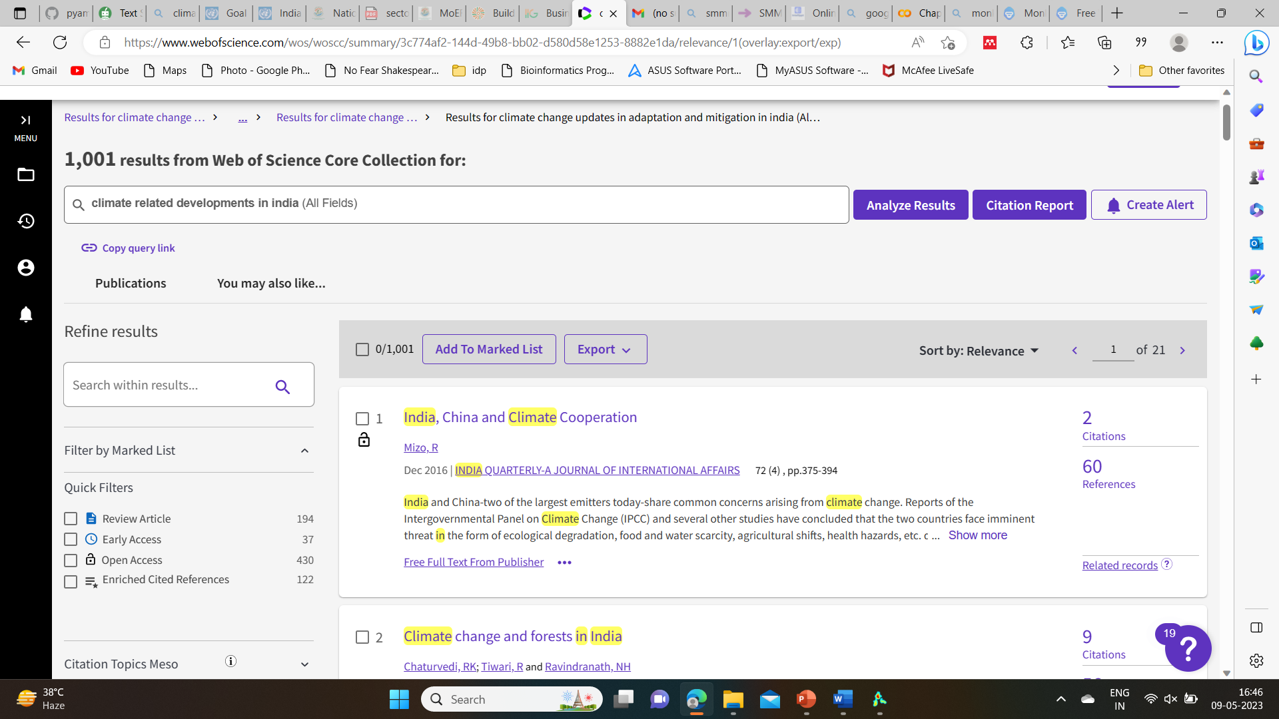Total number of hits: 1001, downloaded text data (title, author and abstract) of 1000 papers.

Figure 28 VOSviewer: overlay visualization

Figure 29 VOSviewer: Density visualization

Figure 30 Web of Science portal

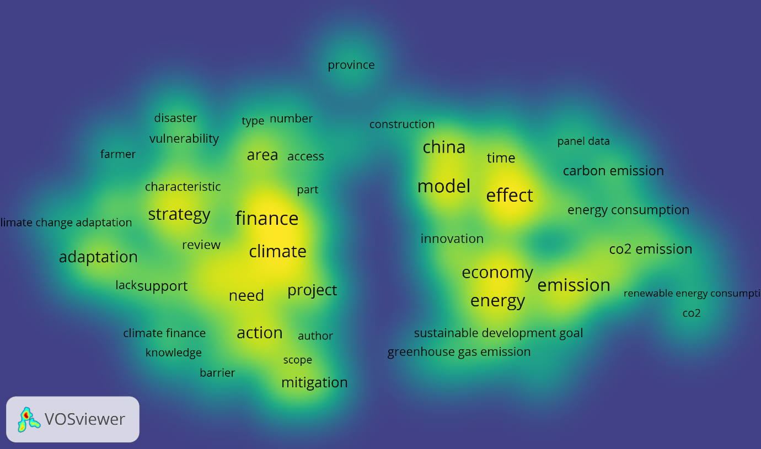

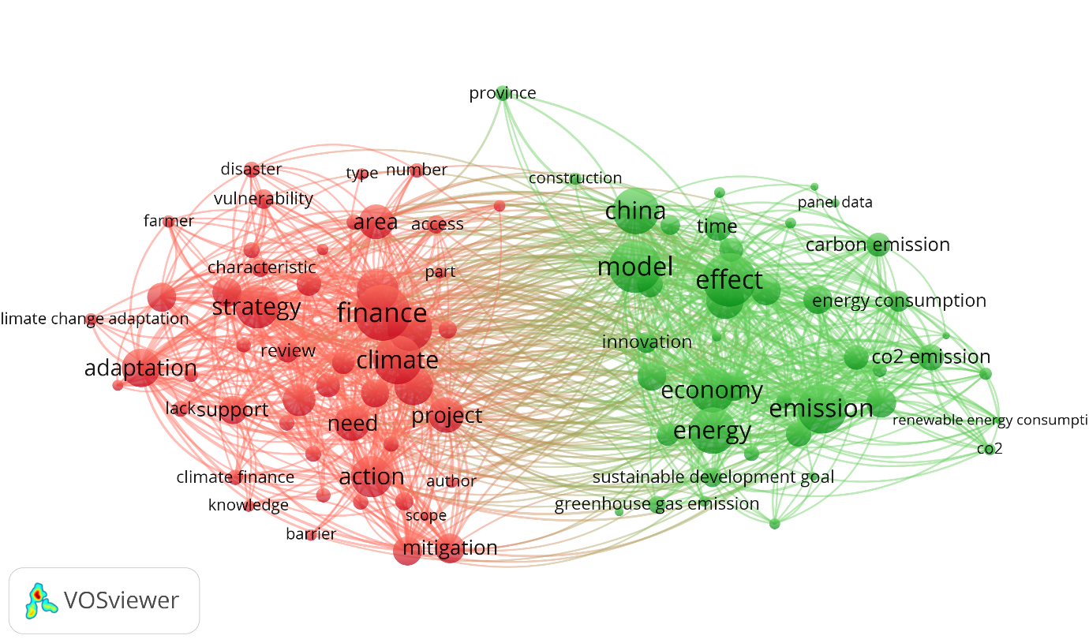

Figure 31 VOSviewer: Network visualization

**Analysis:**

Exploring VOS viewer gives an idea of mapping text data especially, the clustering of data. The logic behind the clustering should still be analysed.

## KNOWLEDGE GRAPHS

Knowledge graphs are the most important and interesting part of text and data mining. These graphs provide us with all the accurate data that is linked together at a glance. Connecting all the climate data with the help of wikibase is a future goal.

**Observations**:

* No proper open-source AI to develop an automated Knowledge graph.
* **Obsidian software** only allows the user to develop a graph by adding nodes manually.
* The existing python code can extract all the nodes and develop a graph (but, is not at a publishable state)

**Results:**

the graph shown below is made manually, by making nodes with the sections of the IPCC CHAPTER 15 ‘FINANCE & INVESTMENT’

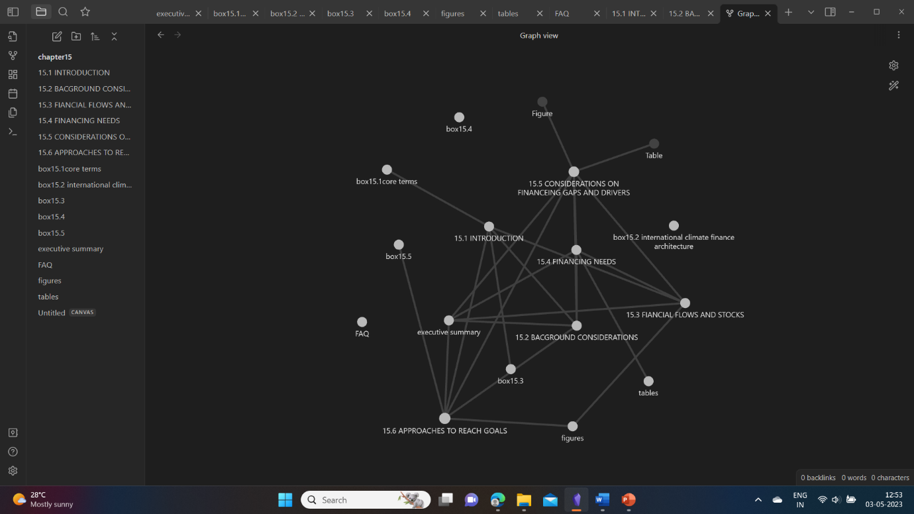For example: node 1 – 15.1, node2 – 15.2, if contents of 15.1 are referred in section 15.2, an edge is created and thus the nodes are connected.

Figure 32 Obsidian environment- knowledge graph

**Python code** used to extract the nodes from the chapter ‘Finance and Investment’ and visualize the source and targets as a knowledge graph.

The edges.csv extracted using this code, contains an ID that is produced along with the target it is connected. The targets are clear (mostly section headings), but the ID’s as of now are unknown (code yet to be developed)

**edges data file on git**:

<https://github.com/petermr/semanticClimate/blob/e0794abeef8d7ecf0a6693717b673eec0399450f/ipcc/ar6/wg3/Chapter15/Knowledge_graph/Edges.csv>

**knowledge graph result, HTML file on GitHub**:

<https://github.com/petermr/semanticClimate/blob/e93aedce33dddb9f2657f0d2b09b55137c17a6eb/ipcc/ar6/wg3/Chapter15/Knowledge_graph/chap15_graph%20(1).html>

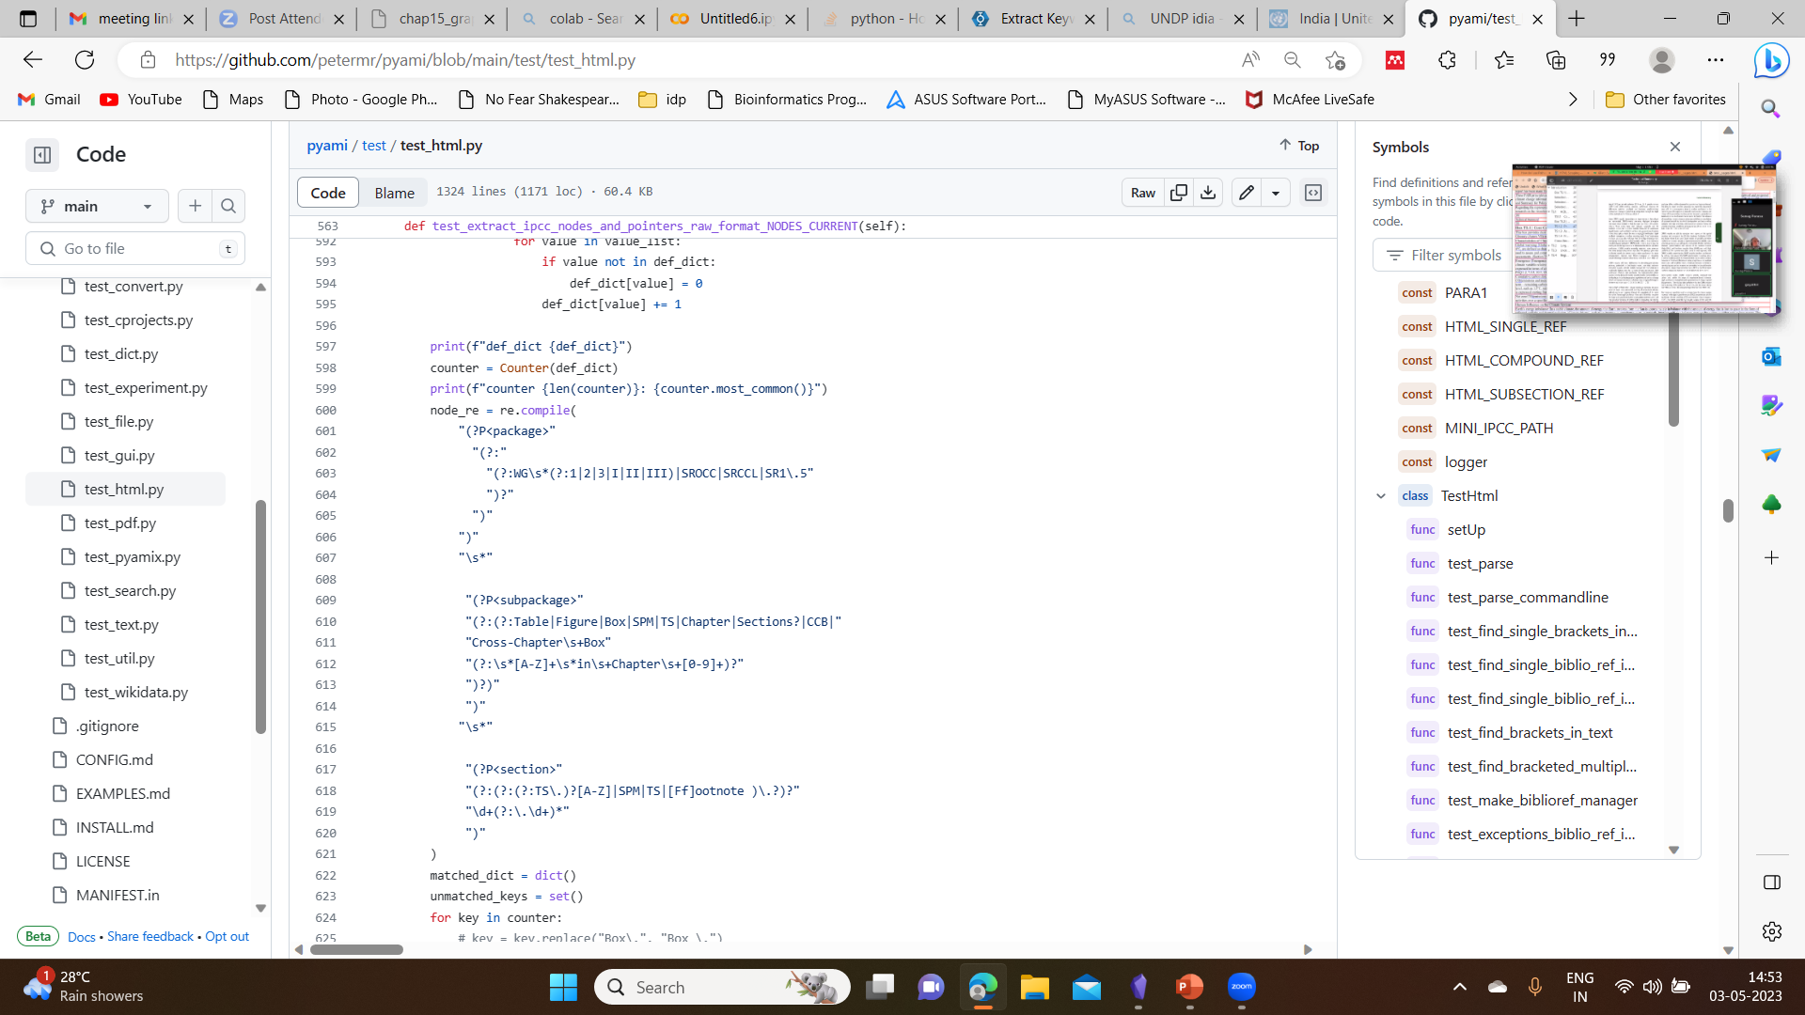

Figure 33 Python code that is used to extract edge from IPCC CHAPTER15 (developed by Dr Peter Murray-Rust)

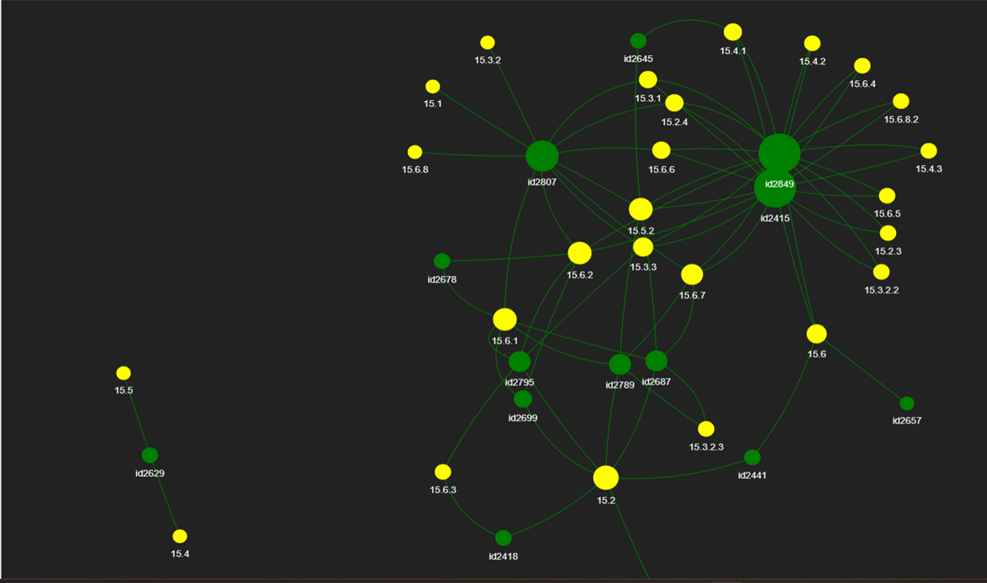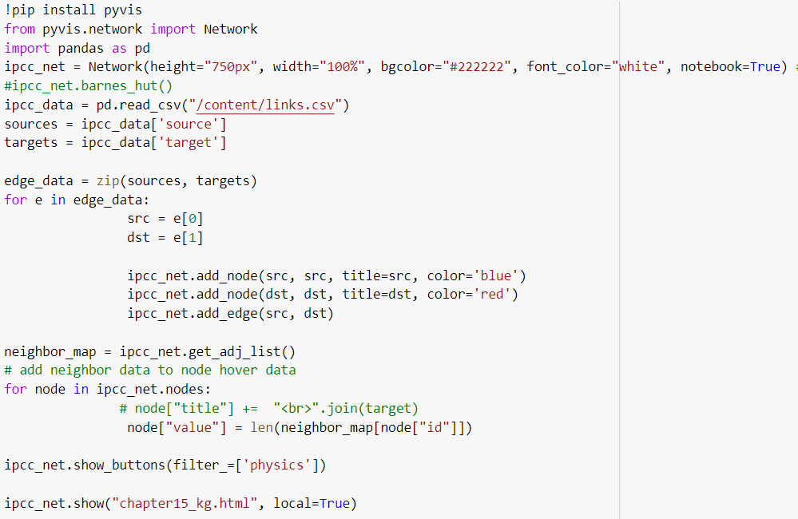python code that helped visualise the knowledge graph

Figure 34 Knowledge graph of chapter ‘Finance & Investment’ developed using python

Figure 35 Python code to visualize the extracted nodes as a knowledge graph

Figure 36 word cloud developed using MonkeyLearnFigure 37 Python code to visualize the extracted nodes as a knowledge graph

# CONCLUSION

The major part of this project work is understanding, analysis and visualization of text data from the IPCC CHAPTER 15 ‘FINANCE AND INVESTEMENT’ and other related data, using various open-source AI tools along with the tools being developed by the team of #SemnaticClimate.

All the Data analysing and visualizing tools explored as a part of the case study, to mine the ‘CLIMATE RELATED DEVELOPMENT’ data, especially for **India**, that contain statistical data related to the provider/donor countries, adaptation finance, mitigation finance, total climate finance provided, sector specific investment and financial instrumental split, have produced good results, that helps us relate to the IPCC chapter form India’s perspective.

The TDM tools used/explored, that are developed by team #SemanticClimate, are useful in analysing the text data and visualizing it for a better and fast understanding without actually spending a lot of time doing it manually.

The main source taken to develop these tools/software’s, by the team is the corpus of IPCC reports, which are actually a moving target, with its change in the updating PDF styles, images and tables which are hard to extract.

The future prospect of this project will be developing the software that connects all the extracted textual data from the IPCC reports along with related data from various sources, through Network/Knowledge graphs with specific wikibase, being developed specially for the climate knowledge.

Optimizing the py4ami software, to make it work on any large scientific literature is the long-term goal of our team #SemanticClilmate.

# REFERENCES

[1] “Data mining - Pattern mining | Britannica.” https://www.britannica.com/technology/data-mining/Pattern-mining (accessed Apr. 18, 2023).

[2] B. M. Ramageri, “DATA MINING TECHNIQUES AND APPLICATIONS,” *Indian Journal of Computer Science and Engineering*, vol. 1, pp. 301–305.

[3] “Text Mining in Data Mining - GeeksforGeeks.” https://www.geeksforgeeks.org/text-mining-in-data-mining/ (accessed Apr. 18, 2023).

[4] “The Paris Agreement | United Nations.” https://www.un.org/en/climatechange/paris-agreement (accessed Apr. 18, 2023).

[5] “Climate Finance | United Nations.” https://www.un.org/en/climatechange/raising-ambition/climate-finance (accessed Apr. 18, 2023).

[6] “Why finance climate action? | United Nations.” https://www.un.org/en/climatechange/why-finance-climate-action (accessed Apr. 18, 2023).

[7] “Aggregate Trends of Climate Finance Provided and Mobilised by Developed Countries in 2013-2020,” Jul. 2022, Doi: 10.1787/D28F963C-EN.

[8] “Profile - venkata.sri.satya.gayathri.jonnalagadda | Tableau Public.” https://public.tableau.com/app/profile/venkata.sri.satya.gayathri.jonnalagadda (accessed May 02, 2023).

[9] “National Action Plan on Climate Change | The Official Website of Ministry of Environment, Forest and Climate Change, Government of India.” https://moef.gov.in/en/division/environment-divisions/climate-changecc-2/national-action-plan-on-climate-change/ (accessed May 09, 2023).

[10] “MoEF&CC.” https://cckpindia.nic.in/ (accessed May 09, 2023).

[11] J. F. B. Mitchell, T. C. Johns, W. J. Ingram, and J. A. Lowe, “The effect of stabilising atmospheric carbon dioxide concentrations on global and regional climate change,” *Geophys Res Lett*, vol. 27, no. 18, pp. 2977–2980, Sep. 2000, doi: 10.1029/1999GL011213.

[12] “CO₂ and Greenhouse Gas Emissions - Our World in Data.” https://ourworldindata.org/co2-and-greenhouse-gas-emissions (accessed May 10, 2023).

[13] “What’s wrong with PDF and why is HTML better?” https://philarcher.org/diary/2018/whatswrongwithpdf/ (accessed Apr. 18, 2023).

[14] “how to improve PDF to HTML conversion · Issue #10 · petermr/semanticClimate.” https://github.com/petermr/semanticClimate/issues/10 (accessed Apr. 18, 2023).

[15] “Keyword Extraction process in Python with Natural Language Processing(NLP) | by Manmohan Singh | Towards Data Science.” https://towardsdatascience.com/keyword-extraction-process-in-python-with-natural-language-processing-nlp-d769a9069d5c (accessed May 02, 2023).

[16] “RAKE Algorithm in Natural Language Processing | What is RAKE?” https://www.analyticsvidhya.com/blog/2021/10/rapid-keyword-extraction-rake-algorithm-in-natural-language-processing/ (accessed May 11, 2023).

[17] “Text Summarizer | QuillBot AI.” https://quillbot.com/summarize (accessed May 05, 2023).

[18] “Online Summarization Tool | PDF Summarizer | Summarize articles, text, documents with IntelliPPT.” https://www.intellippt.com/#summarization (accessed May 05, 2023).

[19] “SMMRY - Summarize articles, text, websites, essays and documents.” https://smmry.com/3726167846#&SM_LENGTH=30 (accessed May 05, 2023).

[20] “Free Word Cloud Generator – MonkeyLearn.” https://monkeylearn.com/word-cloud/ (accessed May 07, 2023).

[21] “Voyant Tools.” https://voyant-tools.org/?corpus=b34d6a9a0d8628ab30bc8b8fb4d6be5d (accessed May 07, 2023).

[22] “voyanttools/Voyant.” https://github.com/voyanttools/Voyant (accessed May 07, 2023).

[23] “VOSviewer - Visualizing scientific landscapes.” https://www.vosviewer.com/ (accessed May 07, 2023).

[24] “What is a Knowledge Graph? | IBM.” https://www.ibm.com/topics/knowledge-graph (accessed May 07, 2023).

[25] “Obsidian.” https://obsidian.md/ (accessed May 07, 2023).